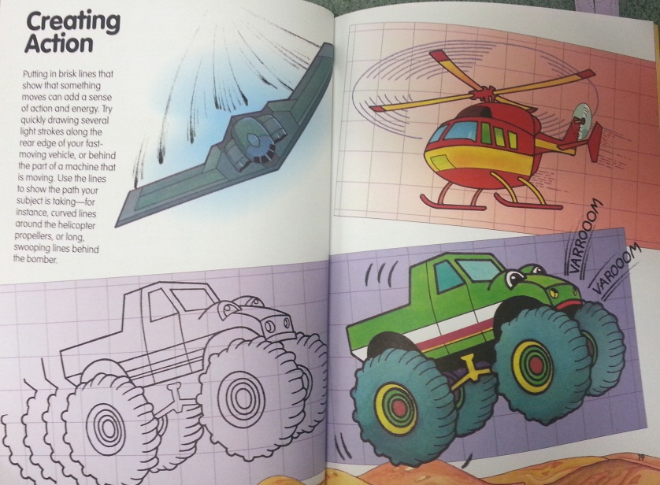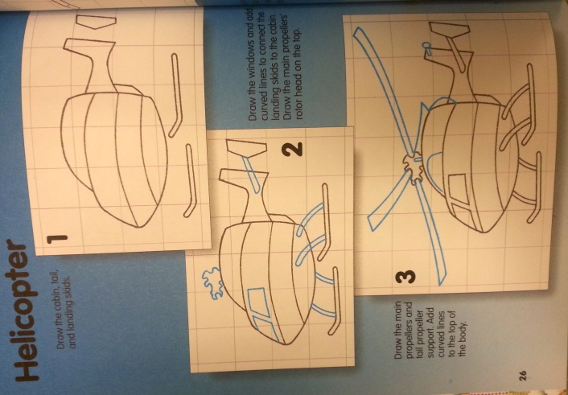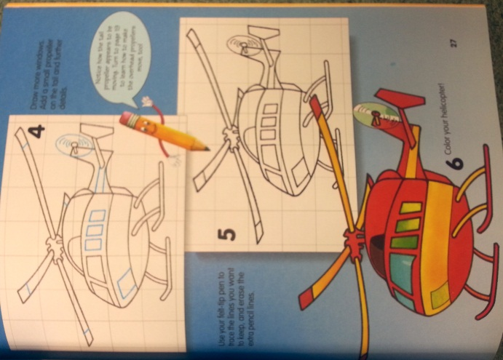

**Wk. 9 Sketches**- Draw the helicopter and add shading to make it look realistic. You do not need to add color. Add movement lines.

**Wk. 9 Sketches**- Draw the helicopter and add shading to make it look realistic. You do not need to add color. Add movement lines.