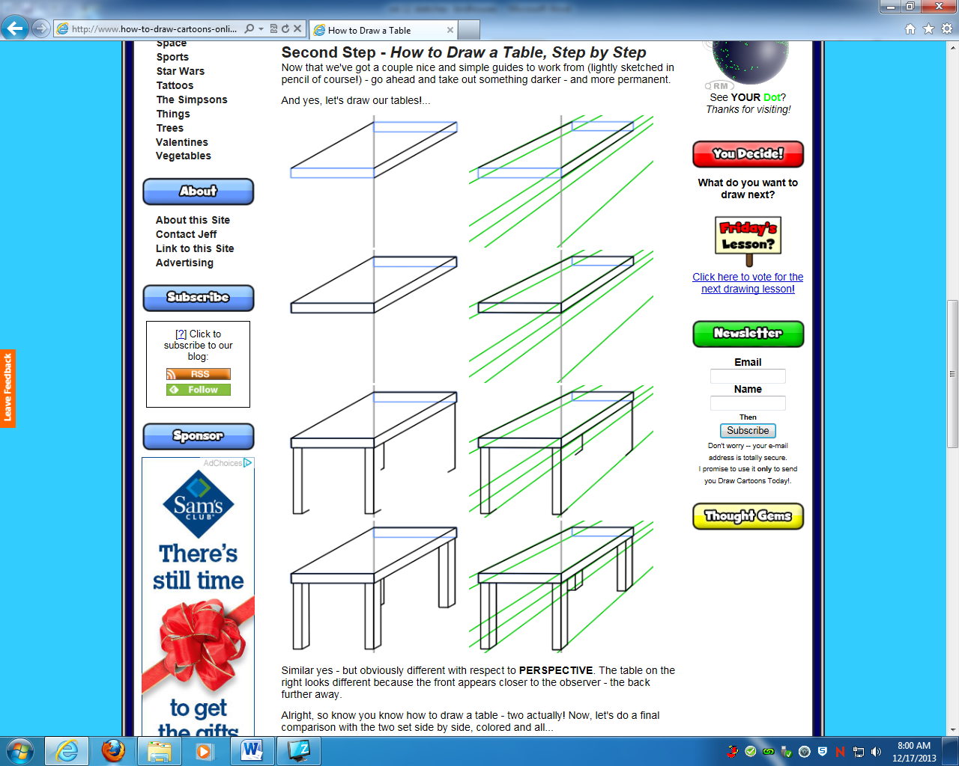

**Wk. 13 Sketches**- Draw the table below. Then find two tables in your house and draw them. Add shading to make it look realistic. You do not need to add color. (The picture on the right side shows the guidelines to help you draw- you do not need to draw this picture).

**Wk. 13 Sketches**- Draw the table below. Then find two tables in your house and draw them. Add shading to make it look realistic. You do not need to add color. (The picture on the right side shows the guidelines to help you draw- you do not need to draw this picture).