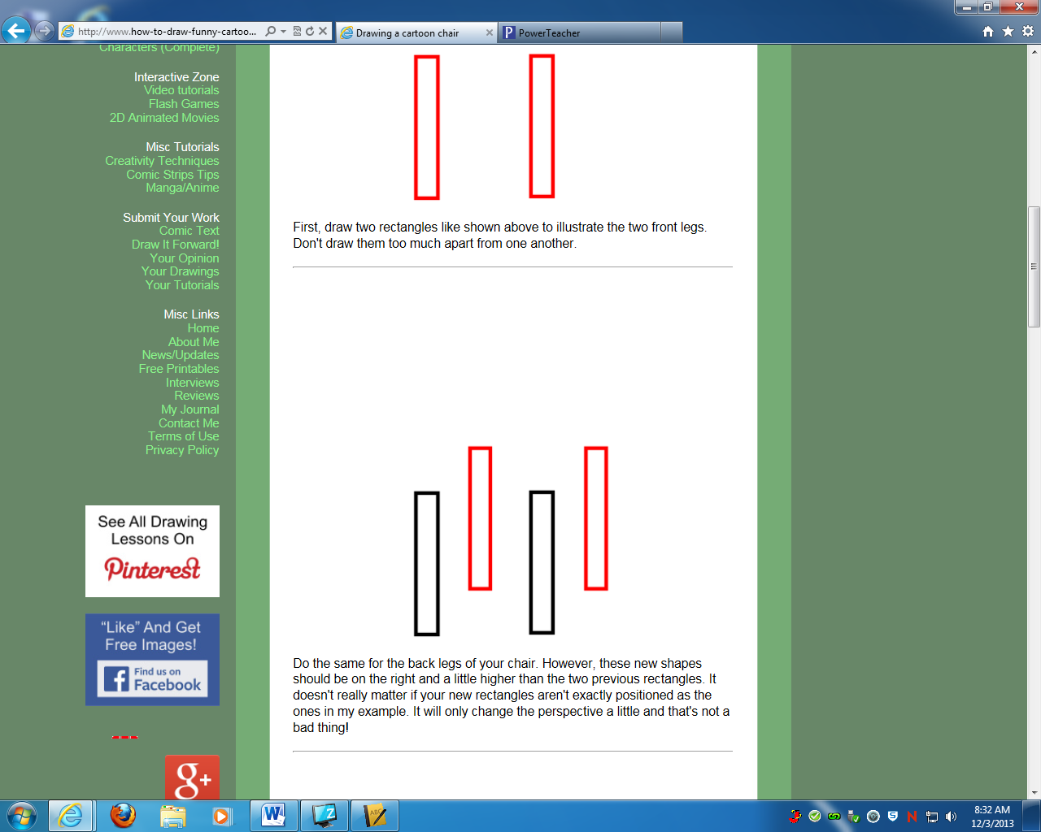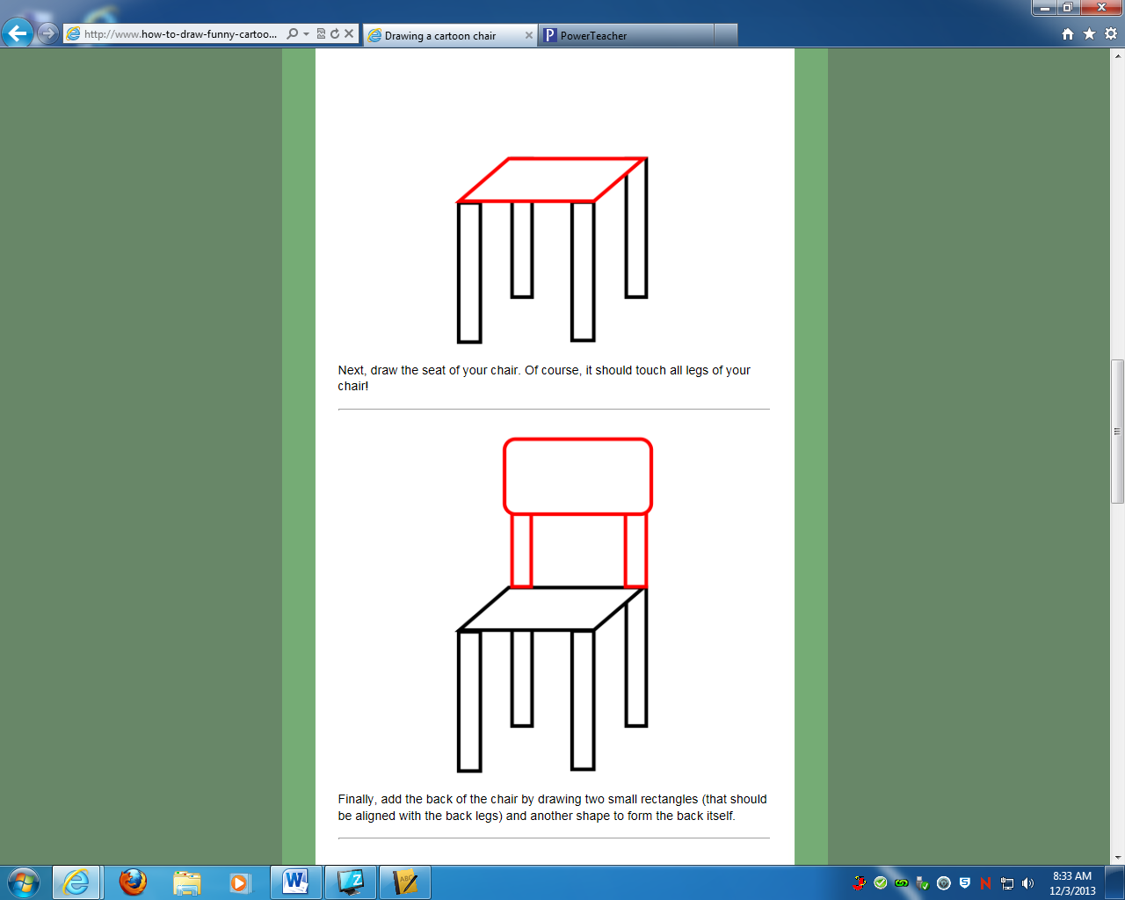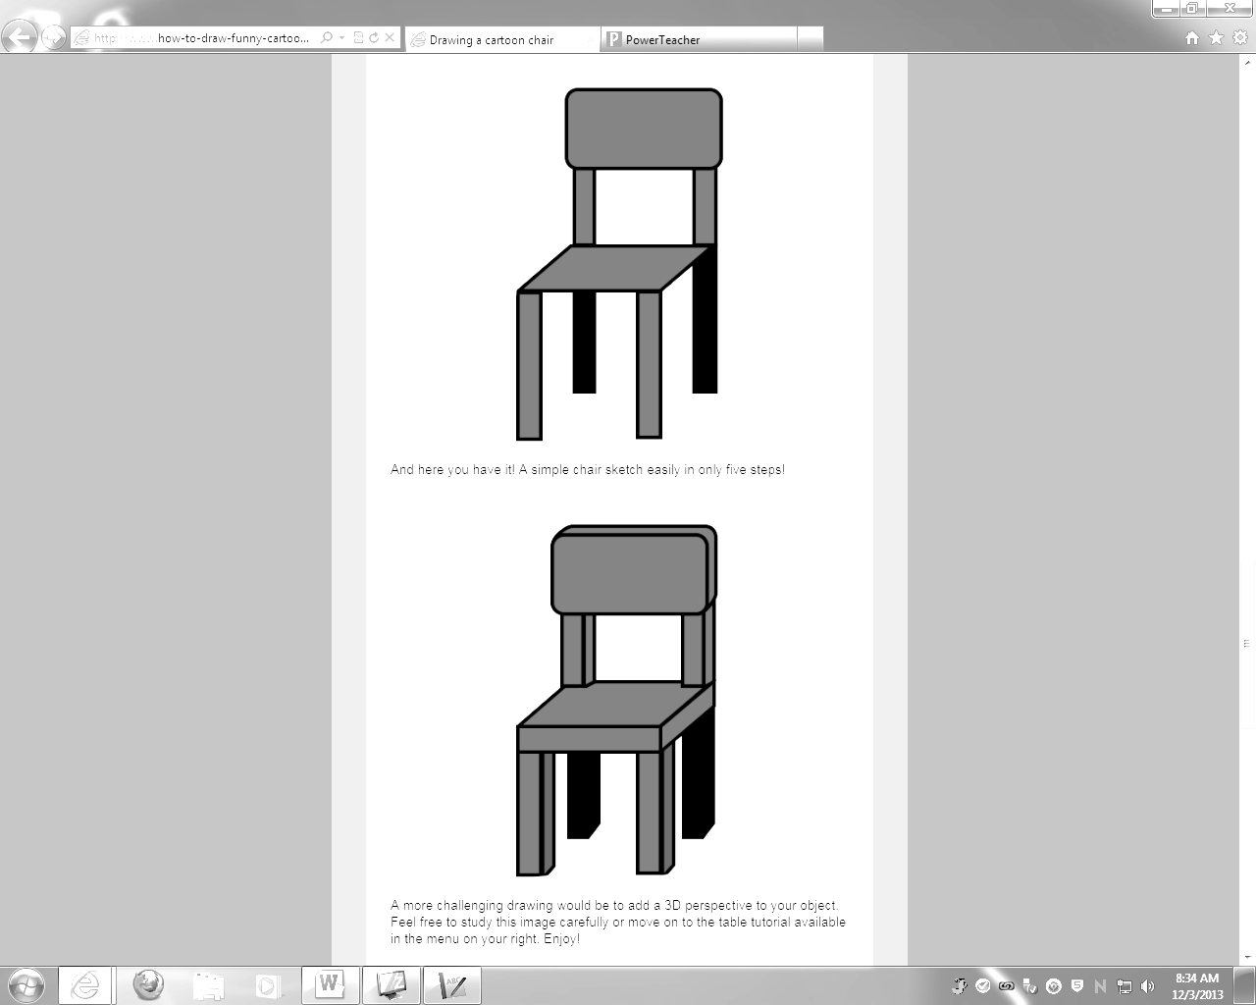

**Wk. 11 Sketches**- Draw the chair and add shading to make it look realistic. You do not need to add color.

**Wk. 11 Sketches**- Draw the chair and add shading to make it look realistic. You do not need to add color.