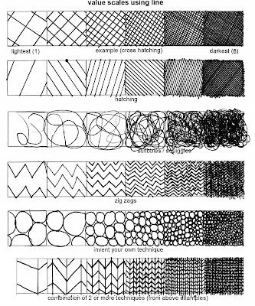
Name_______________________ HR___
Value Scale Using Line
Use the example on the left as a guide to complete the worksheet in your own drawing style. Lines that are farther apart show

Lightest (1) Cross hatching Darkest (7)
Lightest (1) Hatching Darkest (7)
Lightest (1) Scribbles Darkest (7)
Lightest (1) Zig-Zag Darkest (7)
Lightest (1) Circles Darkest (7)
Lightest (1) Combination of 2 Techniques above- (Do NOT copy the example) Darkest (7)

