Notes on….

**VALUE**

**&**

**SHADING**

Name _________________________ HR___

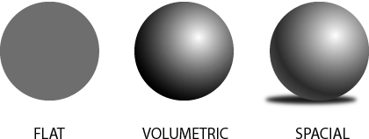

Shape Form - 3D Form - 3D

|  |  |  |  |  |
| --- | --- | --- | --- | --- |
|  |  |  |  |  |

Value:

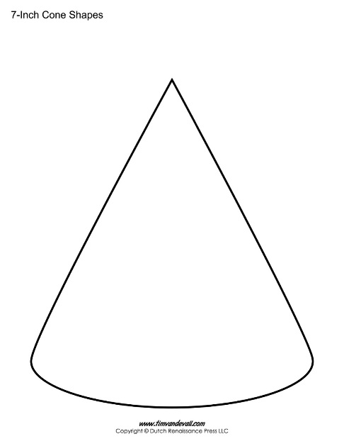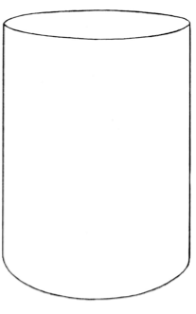

1 2 3 4 5

Light Medium Dark

|  |  |  |  |  |
| --- | --- | --- | --- | --- |
|  |  |  |  |  |

Hatching:

|  |  |  |  |  |
| --- | --- | --- | --- | --- |
|  |  |  |  |  |

Cross Hatching:

|  |  |  |  |  |
| --- | --- | --- | --- | --- |
|  |  |  |  |  |

Stippling:

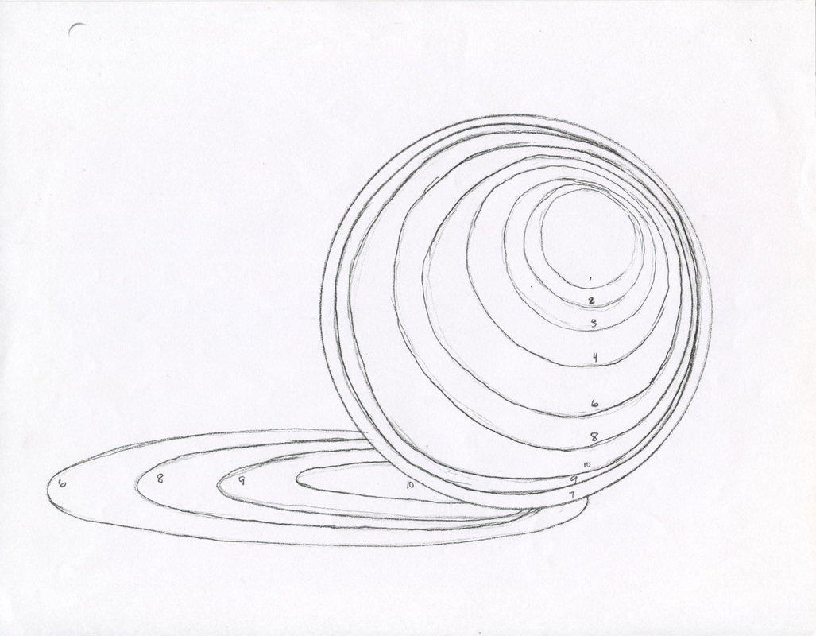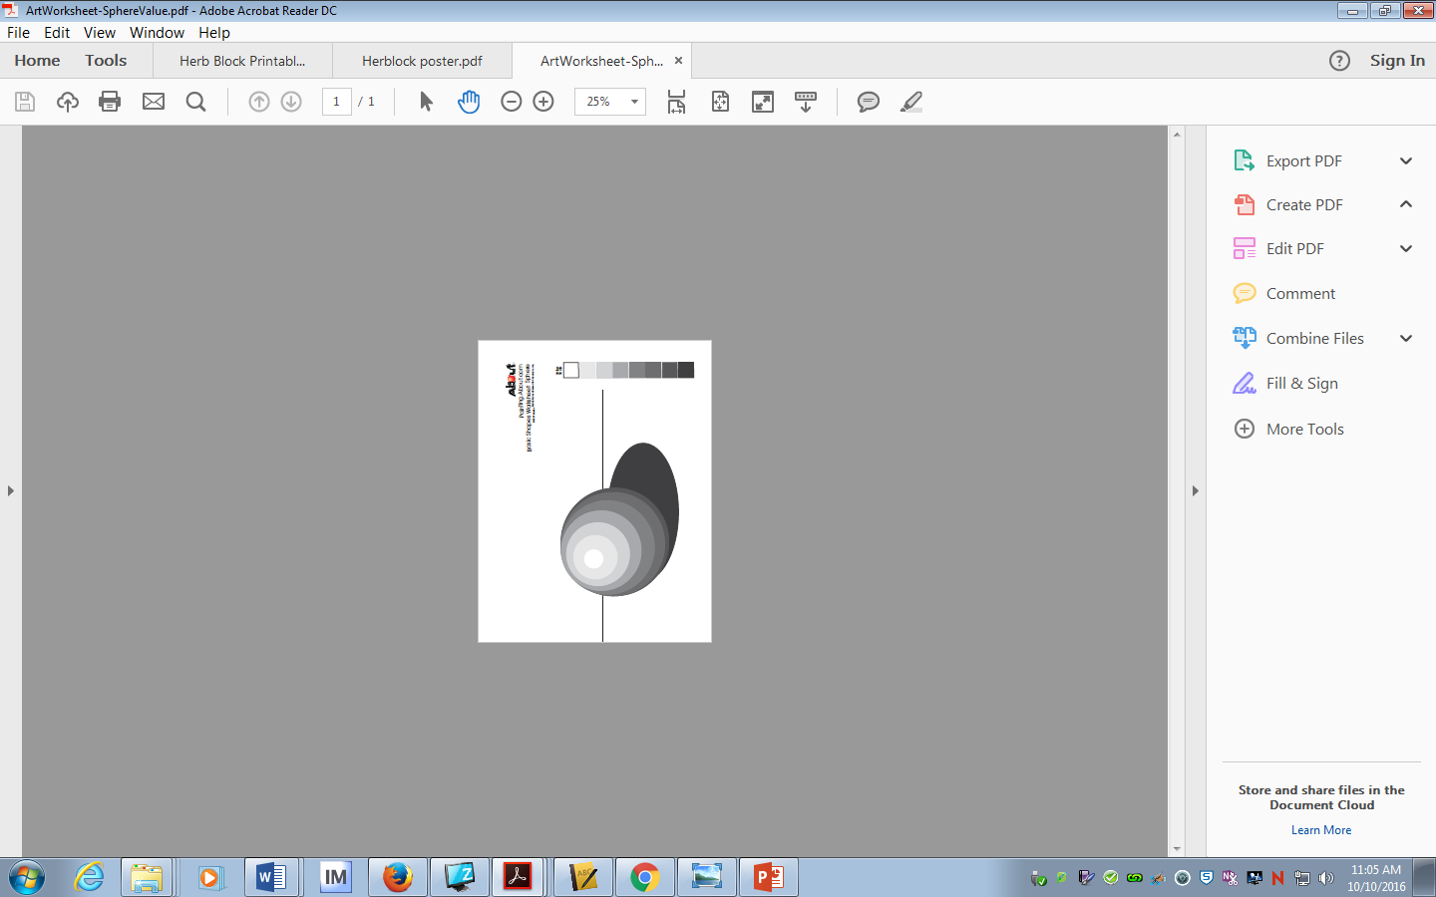

Light Source:

Highlight:

Cast Shadow: