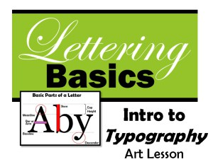
Intro to Typography – Lettering Basics Lesson Plan (Lesson 1) By Michelle East www.createartwithme.com

Typography and graphic design lettering styles play a major role in the area of visual communication and graphic design.
Lettering styles can communication emotion and personality, they can be very powerful! This is the first part of a two part lesson on lettering as an art form.
IO: Learn the basics of letter formation. Learn and identify parts of a letter (anatomy of a letter). Understand that text style is important part of visual communication and that formats are varied to convey different messages.
Day 1
Delivery: The Language of Lettering
- Typography is the design and use of typefaces as a means of communication.
- Typography began with the first printing press-the Gutenberg, but really has its roots in hand-lettering (Calligraphy, Illuminated text, etc.).
- Lettering or typography is a very important part of visual communication. Fonts can communicate strength, power, emotion and personality. Think of some company logos that are just a typeface (Coke, Fender, Canon, etc.) What color are they? What does the construction of the typeface communicate about the company?
- Parts of a Letter:
  - Basic list: Letter Anatomy by Eric Miller -excellent information!
    - Baseline: the invisible bottom line on which characters sit.
    - Meanline: the middle line that is at the top of most lowercase letters such as “o,” “p” and “r.” It is also at the curve of letters like “h.”
    - Cap Height: the distance from the baseline to the top of uppercase letters like “B” and “H.”
    - Ascender: The part of a character that extends above the meanline.
    - Descender: The part of a character that extends below the baseline, such as the bottom stroke of a “g.”
    - Stem: The stem is often the main “body” of a letter. The vertical line of a “B” and the primary diagonal line of a “V”.
    - Crossbar or Arms: Bars are horizontal or diagonal lines of a letter, also known as arms, and are open on at least one side. “E” or “T”
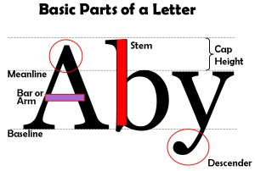

Serifs, Cases & Styles of Lettering
- Serifs: Fonts are often divided into serif and sans serif.
  - Serif fonts are distinguishable by the extra decorative line (style endings) at the ends of the character (examples of serif fonts are Times Roman and Georgia )
  - Sans serif do not have the extra decorative lines. (examples of sans serif fonts are Arial and Impact )
- There are 3 “cases” in lettering: UPPER, lower and Mixed
- 4 Main Styles of Lettering:
- Roman Style, a “thick and thin” letter, often has thickness in different stem places. It usually has “serifs” on each stem end.
- Poster Style, bold or general, is very popular and easy to read. It has even thickness in all directions and may or may not have serif endings.
- Script is a “connected” letter style, can be thick and thin or even thickness. It usually is “italic” or slanted. It is a very graceful, decorative style.
- Unusual or “trademark” text styles are unique and creative. They can be created for specific company logos and are usually copyright protected.

