Jennifer M. Kay-Rivera
Franz marc
Symbolism, Animals & Colors
Warren Consolidated Schools
www.jkay-rivera.weebly.com
jrivera@wcskids.net

View my website for color examples and links to resources for this lesson under the presentation tab.

Course- Drawing & Painting, Art Foundations- High School

Objective- To utilize symbolism, color and a totem animal to create meaning in art.

Time Frame- 2-3 weeks

Materials- Standard white drawing paper or construction paper ruler
Pencil oil pastels (or chalk pastels) colorless blender (by Cray-Pas)

Presentation- Give a presentation about Franz Marc and realism. Scholastic Art featured Marc in the November 2009 issue. Students read about the artist and answer questions related to his artwork and process using the Scholastic Art Magazine. Discuss symbolism in objects in color. Students will then research their totem animal and select symbolism and colors appropriate to the meaning they wish to portray in their artwork. Students will also include a celestial element that has meaning for them. Demonstrate to students a variety of techniques to achieve color blending with oil pastels and how to use the blender extender. Students will also need to select a color scheme for each component of the drawing (animal, celestial element, background).

Totem Animal Research:
http://www.whats-your-sign.com/water-animal-totems.html
http://www.whats-your-sign.com/land-animal-totems.html
http://www.whats-your-sign.com/air-animal-totems.html

Directions- Students will sketch and layout the design of their animal and celestial element. Then they will draw the grid system over the entire drawing. The grid system should have a variety of compartment sizes to create a unique look. Each piece of the grid will be blended in a different way to stand out.

Evaluation:
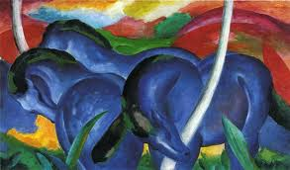
Student Work

Work by Franz marc

