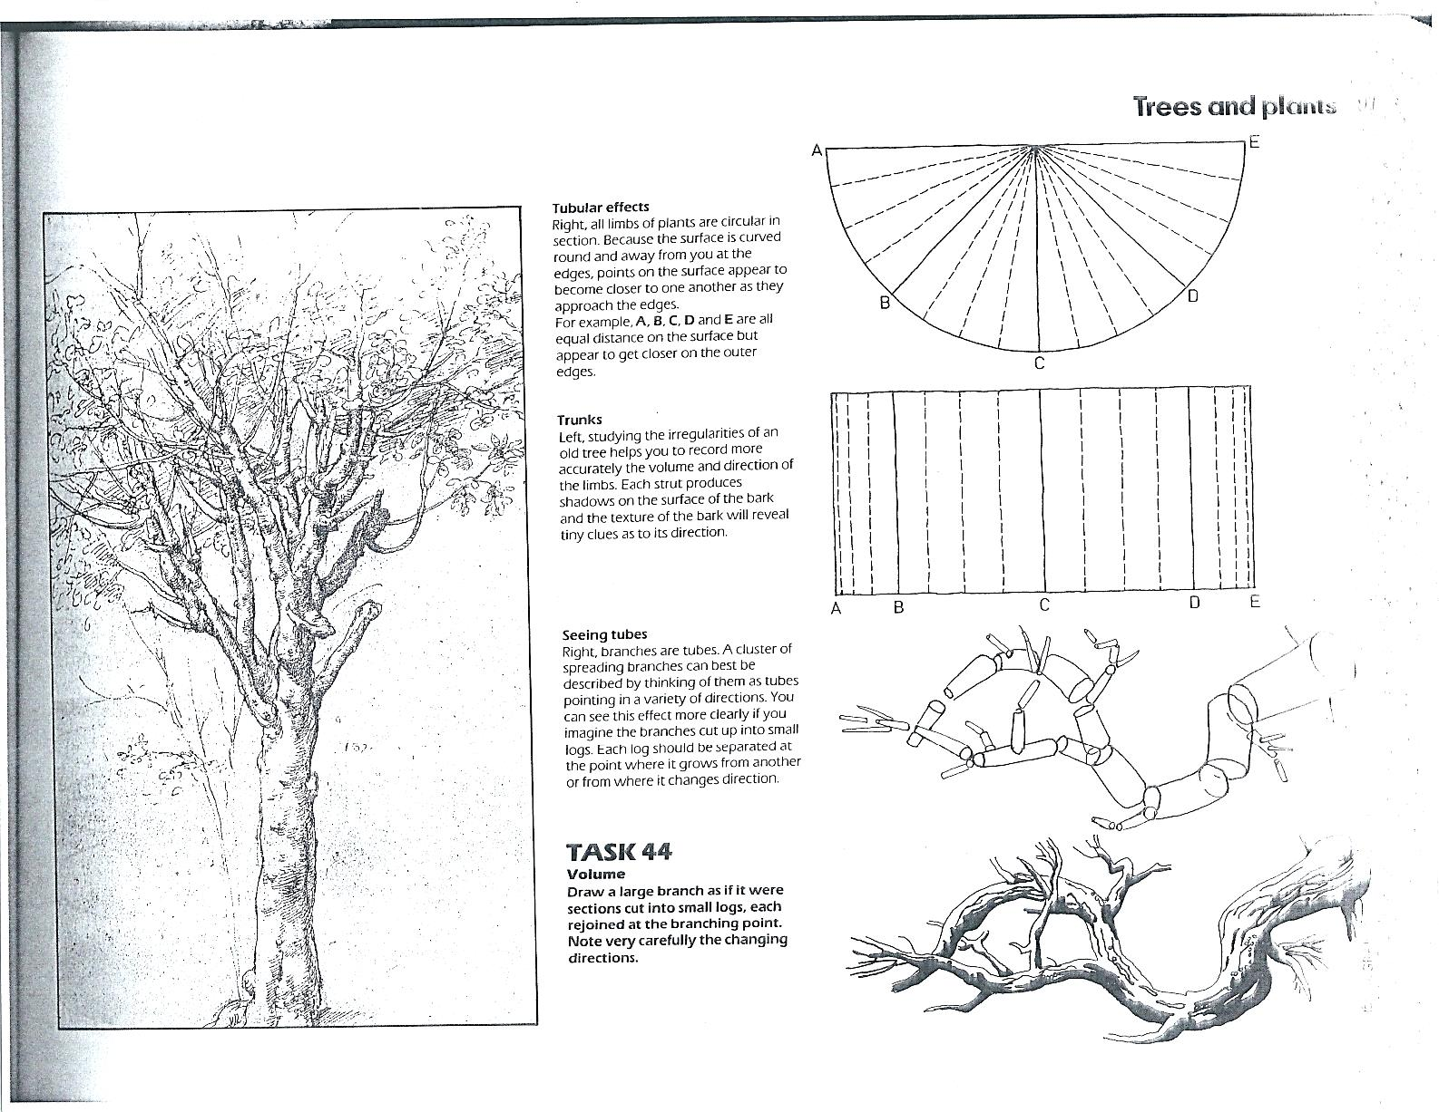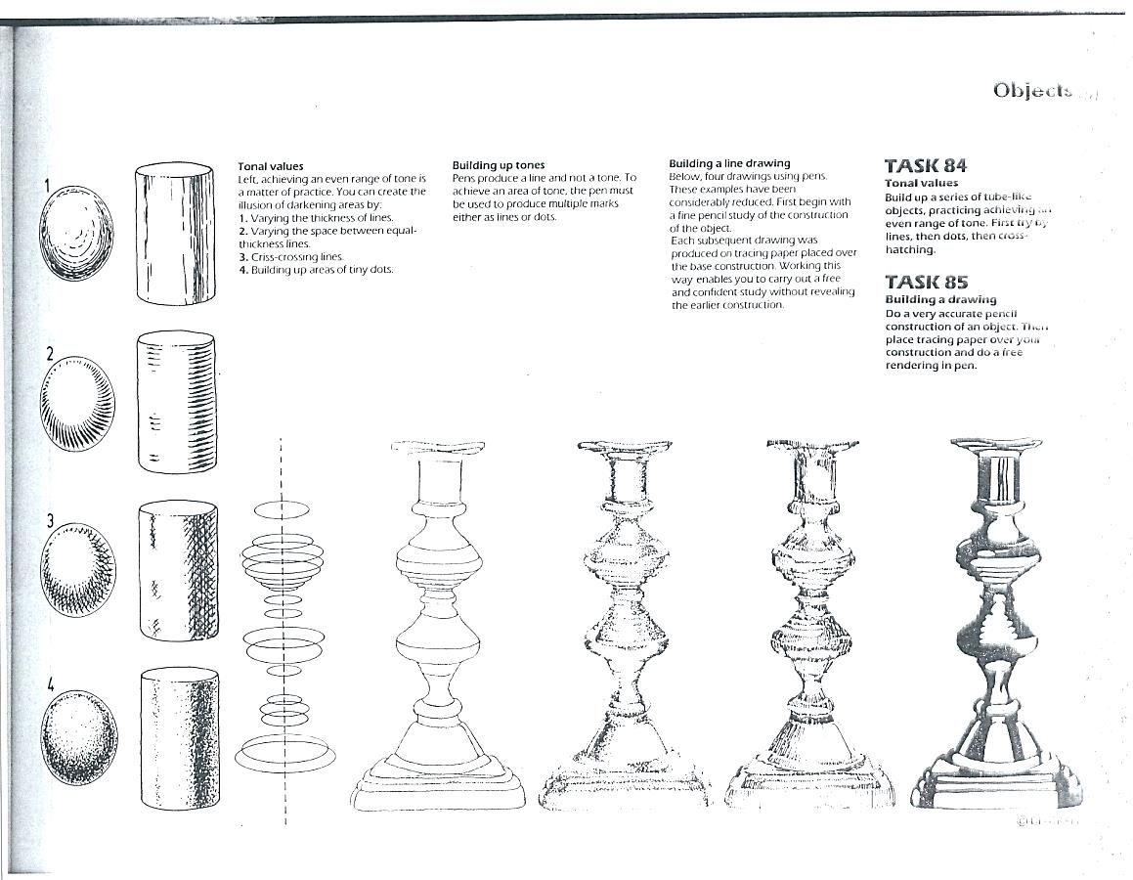

Technique 1- short curved lines

Technique 2- short lines from the edge

Technique 3- cross hatching, overlapped lines in 2 directions

Technique 4- stippling, close dots= dark, farther apart dots= light

1 2 3 4

Technique 1- short curved lines

Technique 2- short lines from the edge

Technique 3- cross hatching, overlapped lines in 2 directions

Technique 4- stippling, close dots= dark, farther apart dots= light

1 2 3 4

**Drawing & Painting**

**Sketchbook Week 3- Drawing Objects with Dimension**

**-Top Photo**- redraw all the objects in the top photo

(circles, cylinders, candlesticks) w/the different techniques

**-Bottom Photo**- redraw the two versions of the tree branches

**Drawing & Painting**

**Sketchbook Week 3- Drawing Objects with Dimension**

**-Top Photo**- redraw all the objects in the top photo, each

w/the 4 different techniques (circles, cylinders, candlesticks) **-Bottom Photo**- redraw the two versions of the tree branches