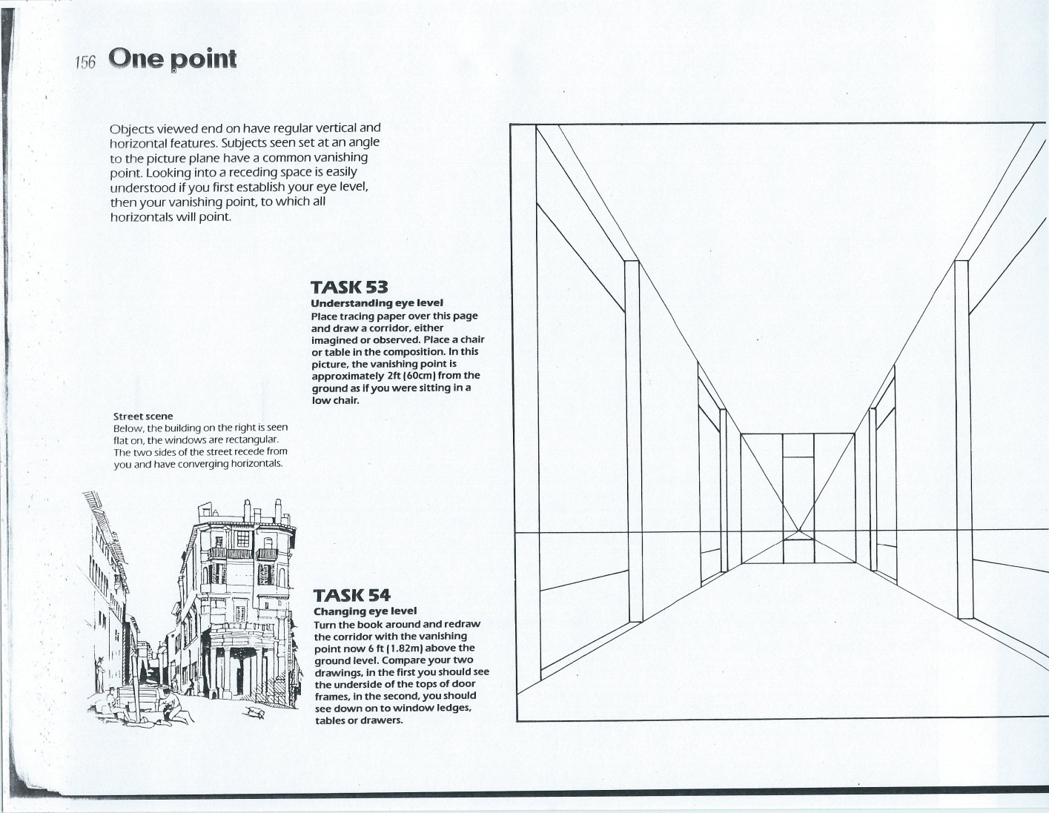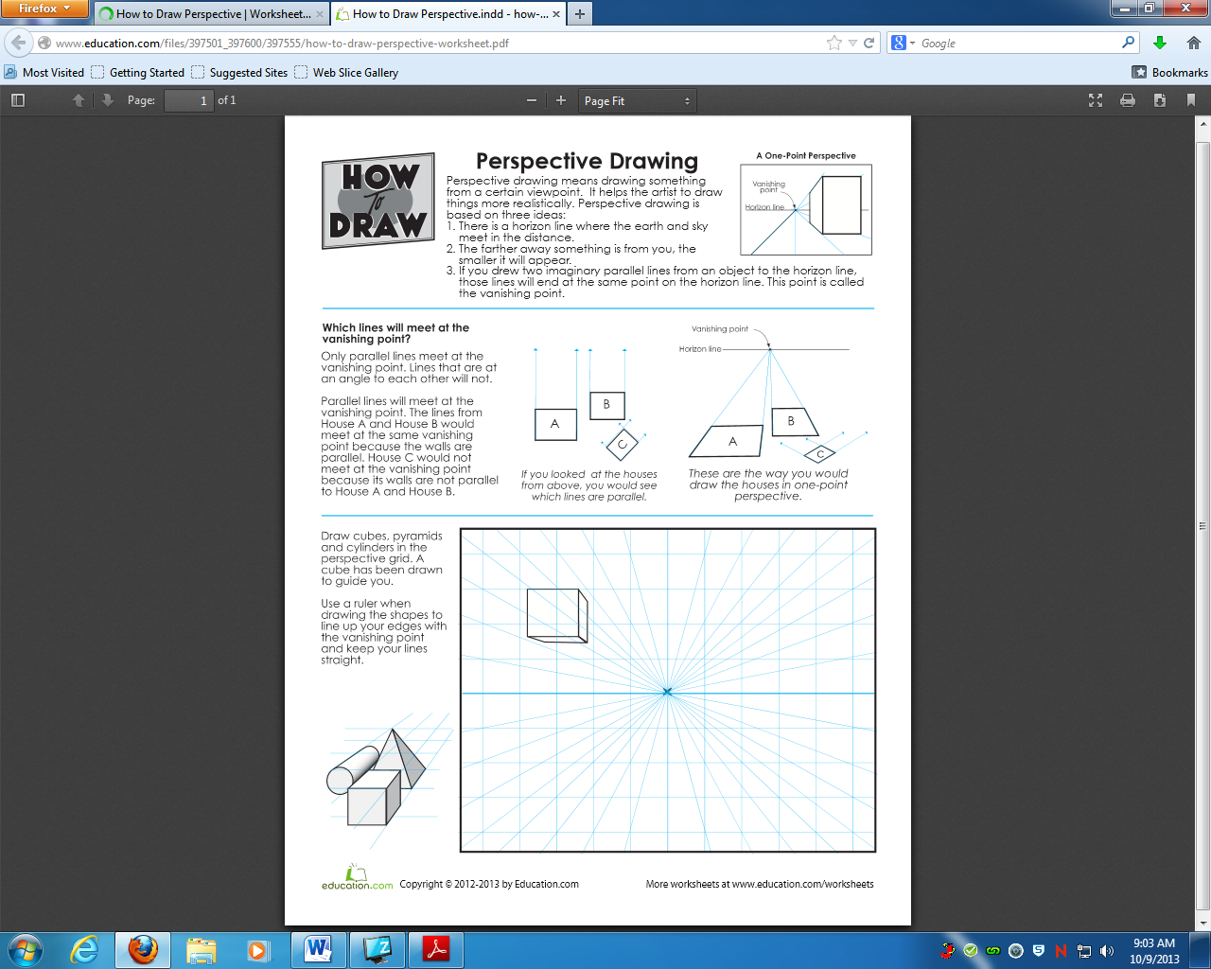

**Drawing & Painting Sketchbook Week 1 -One Point Perspective**

Follow the directions for drawing in perspective. Draw the bottom two pictures using 1 pt perspective - the three shapes & the room.

**Drawing & Painting Sketchbook Week 1 -One Point Perspective**

Follow the directions for drawing in perspective. Draw the bottom two pictures using 1 pt perspective - the three shapes & the room.