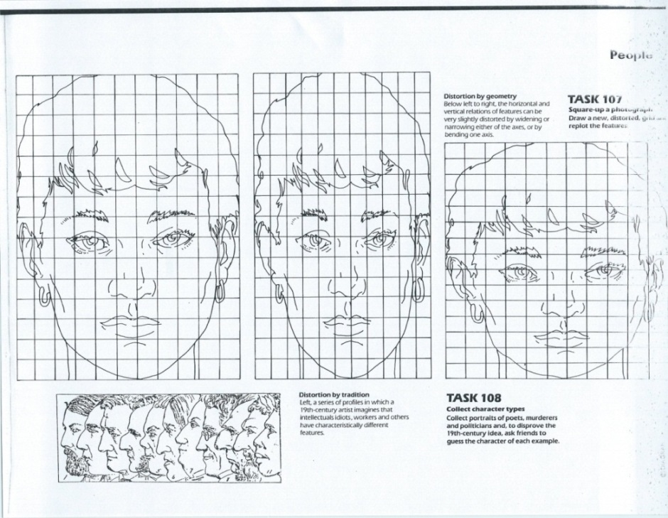Example- Original Photo stretched Vertically Stretched Horizontally

**Drawing & Painting Sketchbook Week** **7**- **Distorting Portraits using a grid**

Re draw the faces A & B from the original photo grid to the grid on the right to make the face taller or wider.

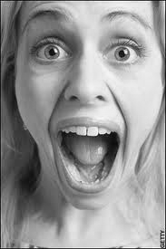

|  |  |  |  |  |  |  |
| --- | --- | --- | --- | --- | --- | --- |
|  |  |  |  |  |  |  |
|  |  |  |  |  |  |  |
|  |  |  |  |  |  |  |
|  |  |  |  |  |  |  |
|  |  |  |  |  |  |  |
|  |  |  |  |  |  |  |
|  |  |  |  |  |  |  |

|  |  |  |  |  |  |  |
| --- | --- | --- | --- | --- | --- | --- |
|  |  |  |  |  |  |  |
|  |  |  |  |  |  |  |
|  |  |  |  |  |  |  |
|  |  |  |  |  |  |  |
|  |  |  |  |  |  |  |
|  |  |  |  |  |  |  |
|  |  |  |  |  |  |  |

|  |  |  |  |  |  |  |
| --- | --- | --- | --- | --- | --- | --- |
|  |  |  |  |  |  |  |
|  |  |  |  |  |  |  |
|  |  |  |  |  |  |  |
|  |  |  |  |  |  |  |
|  |  |  |  |  |  |  |
|  |  |  |  |  |  |  |
|  |  |  |  |  |  |  |

**Face A**

|  |  |  |  |  |  |  |
| --- | --- | --- | --- | --- | --- | --- |
|  |  |  |  |  |  |  |
|  |  |  |  |  |  |  |
|  |  |  |  |  |  |  |
|  |  |  |  |  |  |  |
|  |  |  |  |  |  |  |
|  |  |  |  |  |  |  |
|  |  |  |  |  |  |  |

****Face B