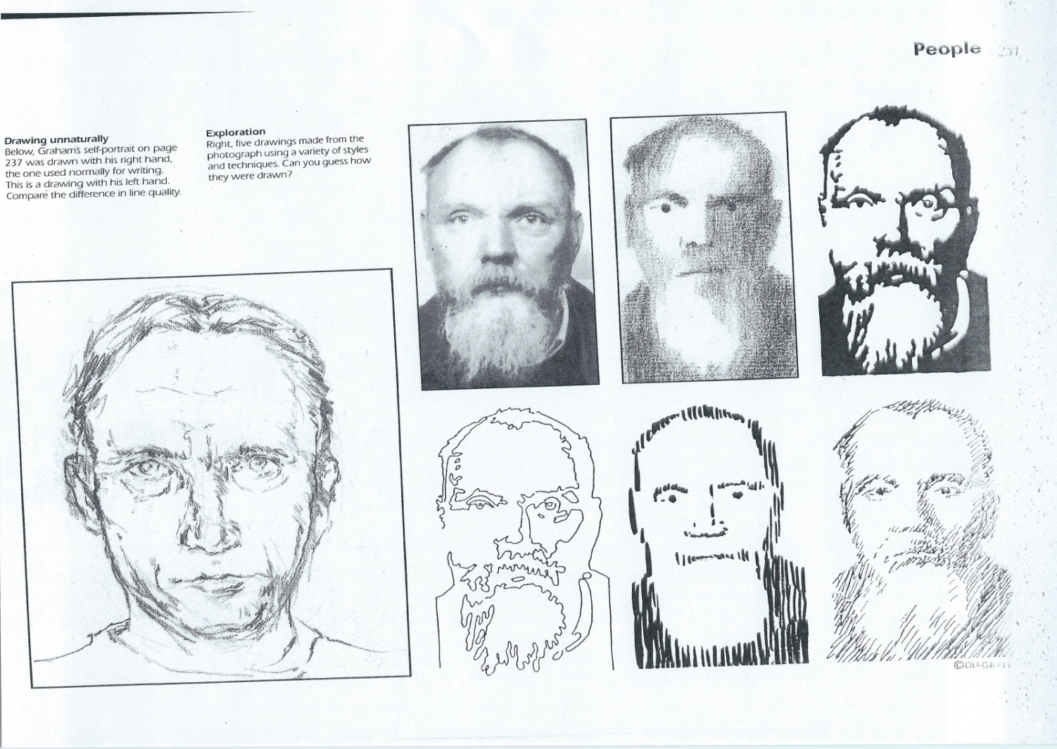

Original Photo Drawing from Photo 1)find dark areas of the face

2)contour lines 3)use short vertical lines 4)use short diagonal lines in the dark areas

**Drawing & Painting Sketchbook Week 4- Techniques for Drawing People**

Draw a person (in real life or from a photo) using the techniques in pictures 1, 2, 3, 4



Original Photo Drawing from Photo 1)find dark areas of the face

2)contour lines 3)use short vertical lines 4)use short diagonal lines in the dark areas

**Drawing & Painting Sketchbook Week 4- Techniques for Drawing People**

Draw a person (in real life or from a photo) using the techniques in pictures 1, 2, 3, 4