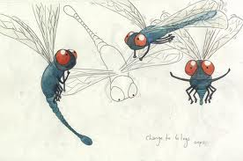

**Drawing & Painting Sketchbook Week** **14- Contour Object**

Find a picture of an object. Draw the picture showing three different views or angles in contour drawing

**Drawing & Painting Sketchbook Week** **14- Contour Object**

Find a picture of an object. Draw the picture showing three different views or angles in contour drawing