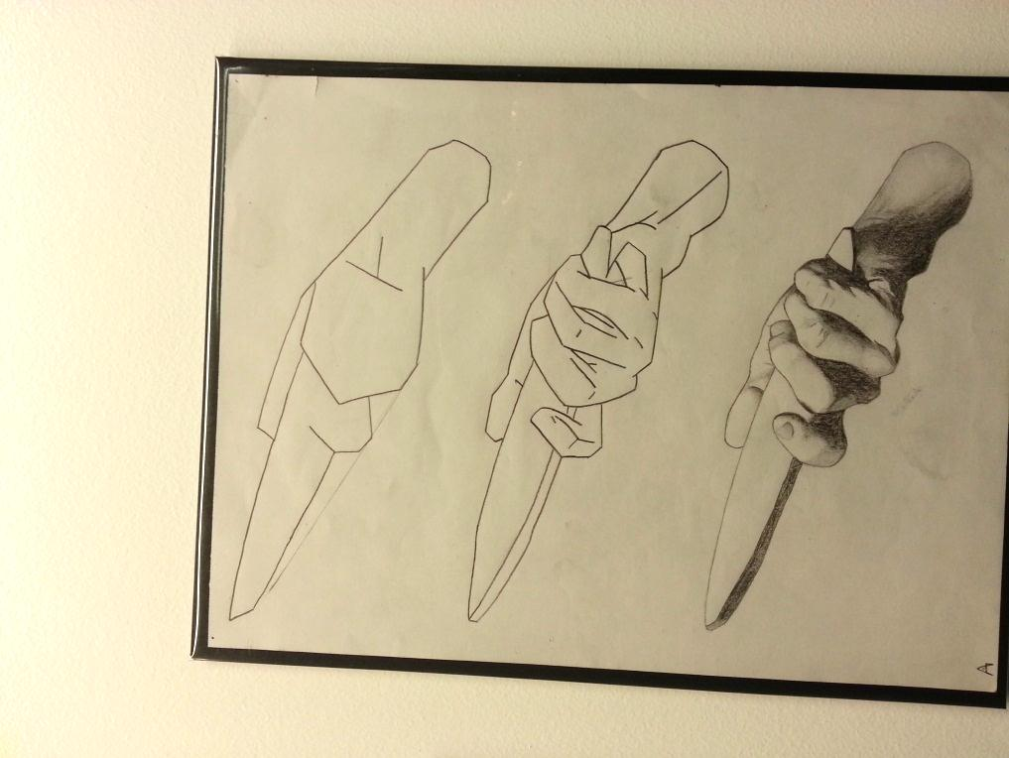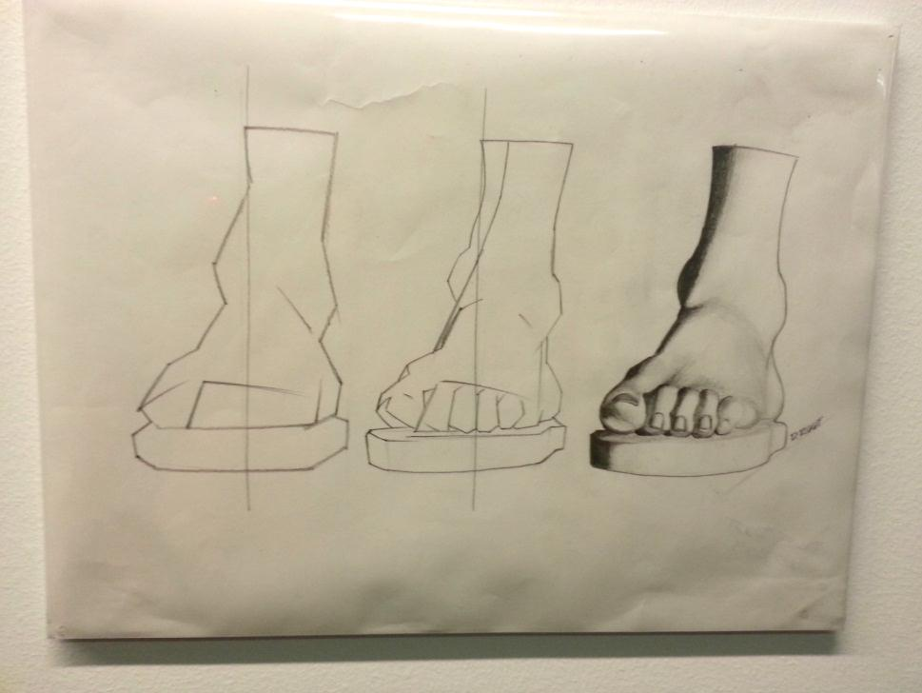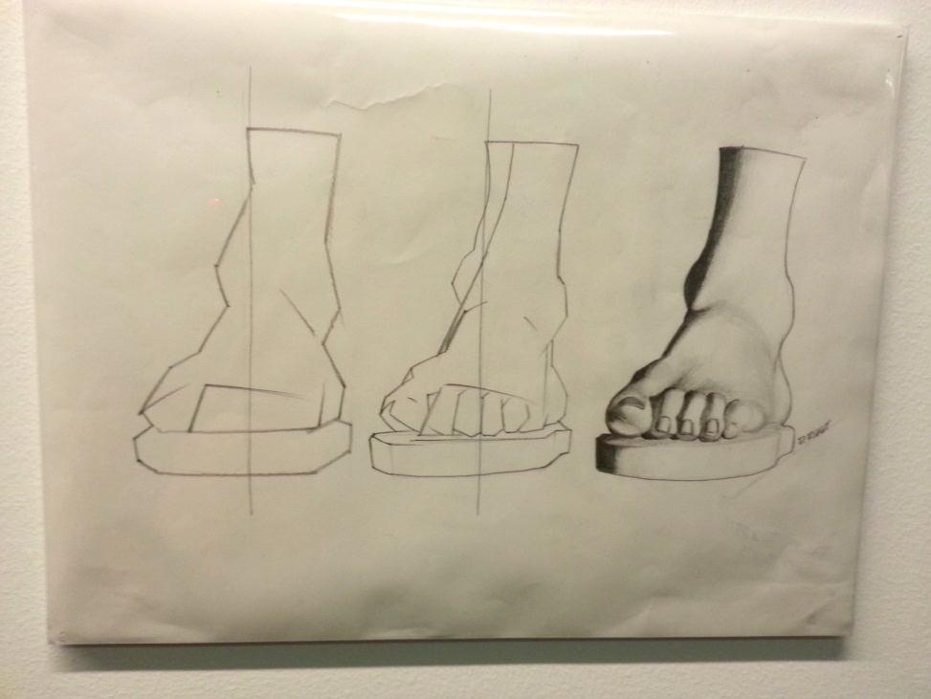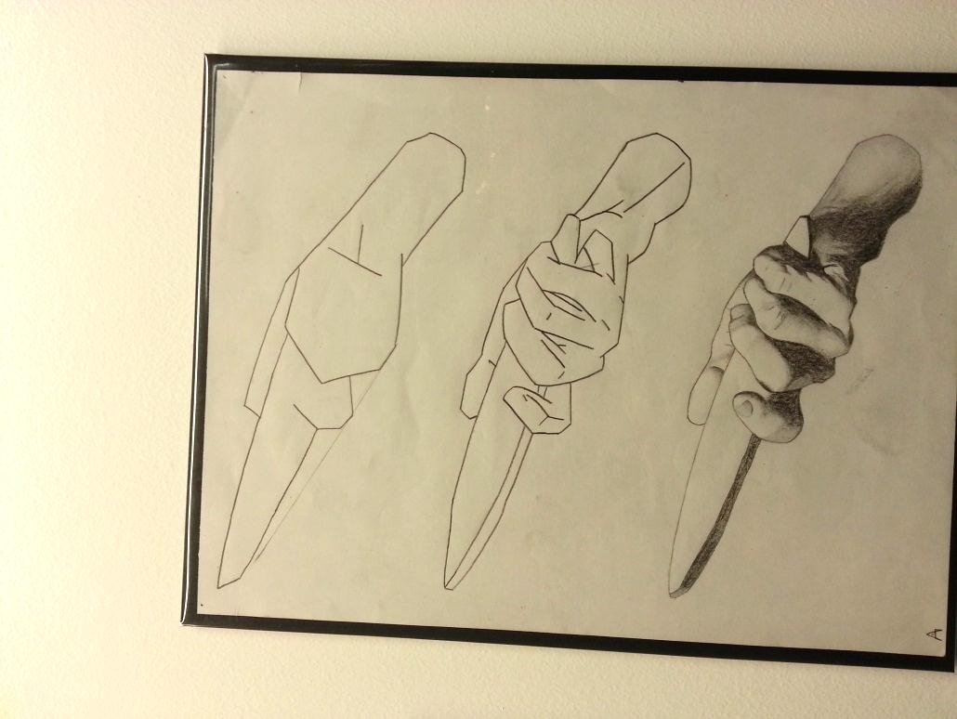

**Drawing & Painting Sketchbook Week** **13- Shaped to Object**

Find a picture of an object. Draw the picture finding the contour, then shapes , then realistic.

Create 2 sets of these drawings.

**Drawing & Painting Sketchbook Week** **13- Shaped to Object**

Find a picture of an object. Draw the picture finding the contour, then shapes , then realistic.

Create 2 sets of these drawings.