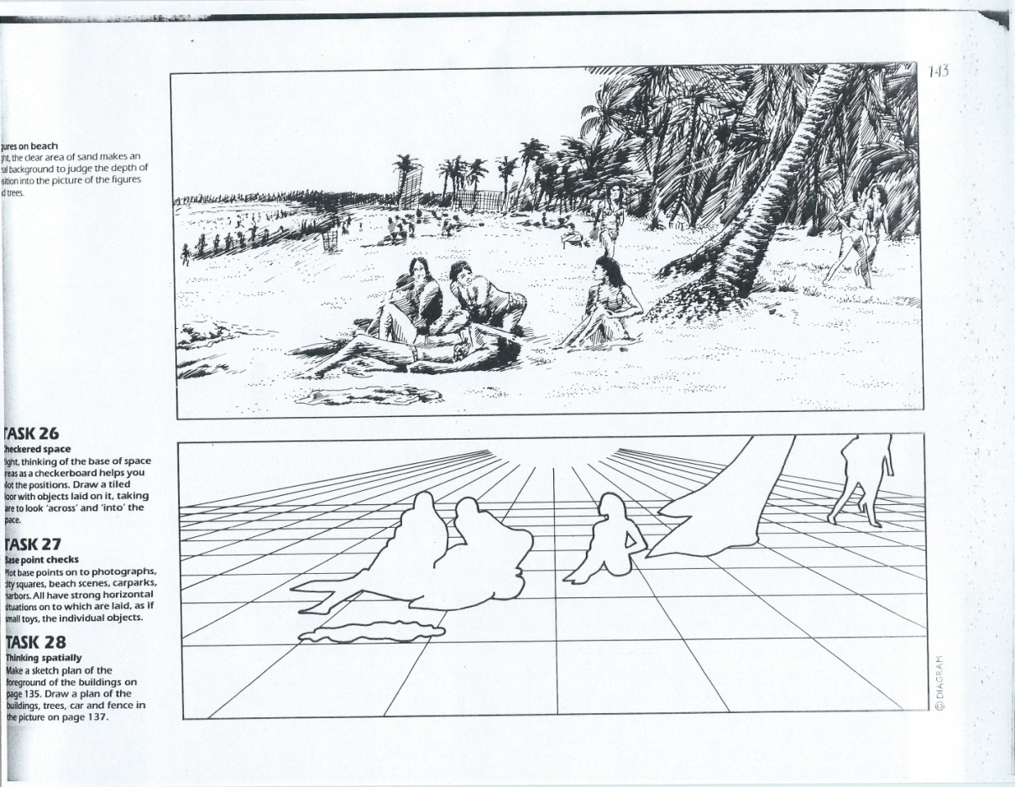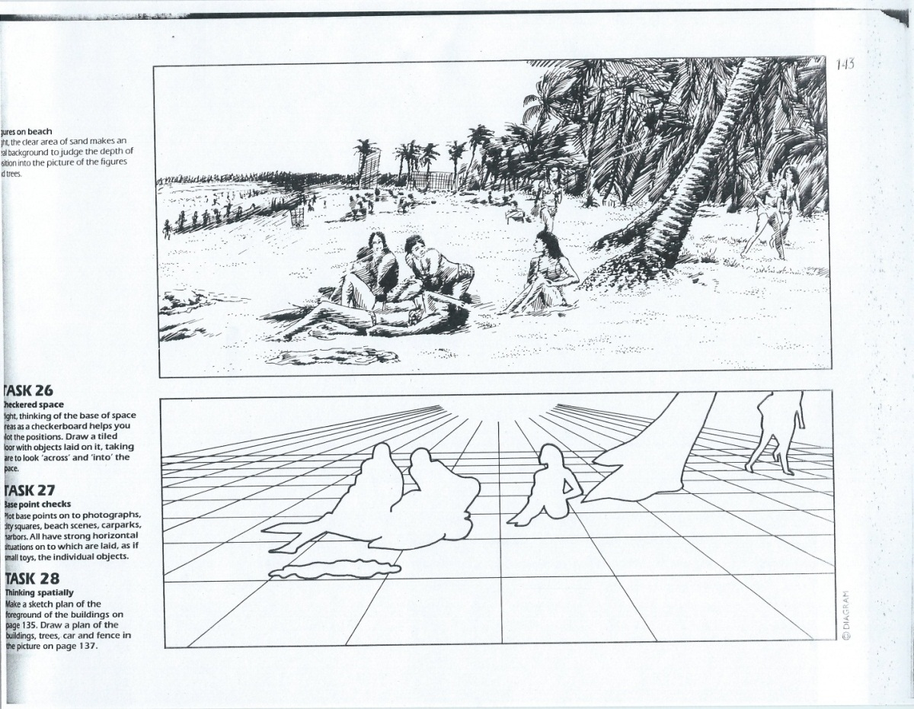

**Drawing & Painting Sketchbook Week** **12- Thinking Spatially**

Find a magazine picture or print one from the computer of people in landscape. Glue the picture in your sketchbook. Draw the land with a perspective grid, the people and major land forms in contour.

Create 2 drawings. An example is below.

**Drawing & Painting Sketchbook Week** **12- Thinking Spatially**

Find a magazine picture or print one from the computer of people in landscape. Glue the picture in your sketchbook. Draw the land with a perspective grid, the people and major land forms in contour.

Create 2 drawings. An example is below.