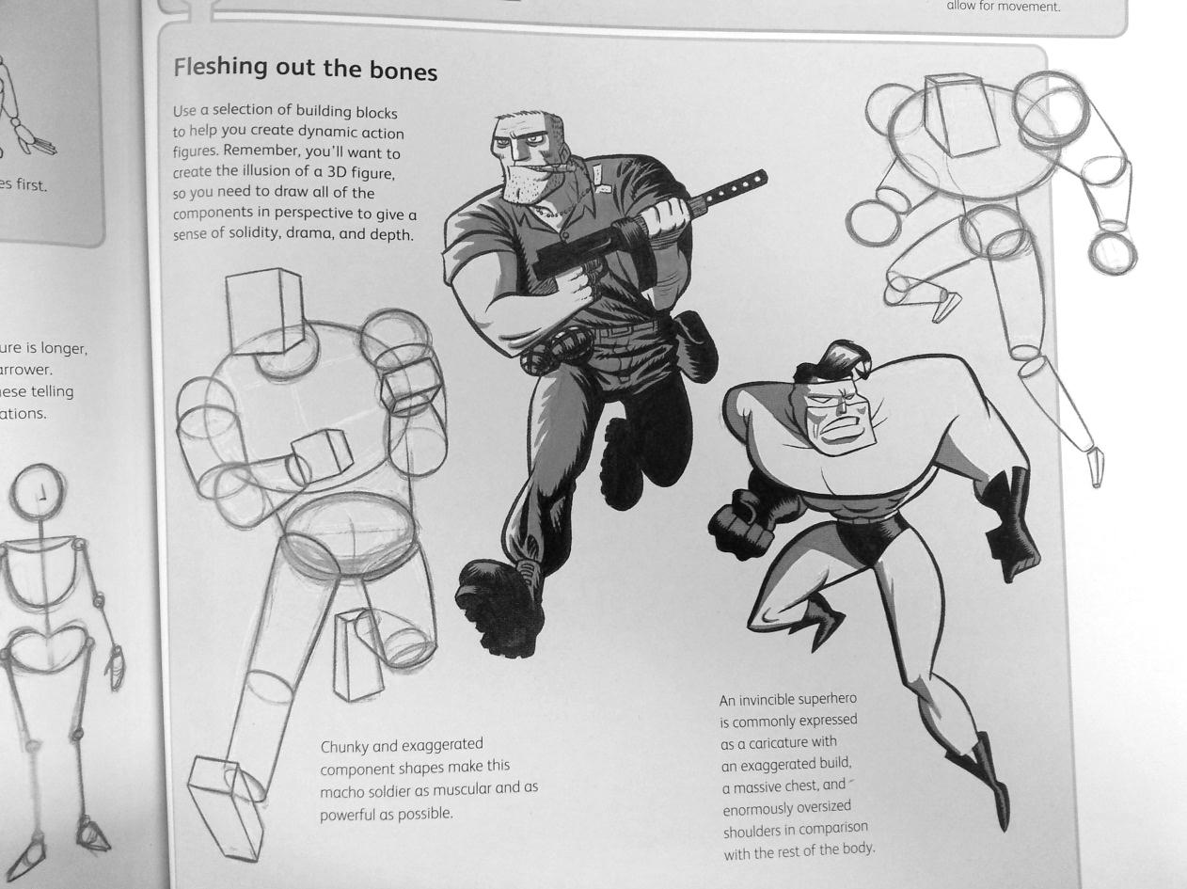

**Drawing & Painting Sketchbook Week** **11- Finding Shapes in Figures**

Find and print a picture of a person including their body. Glue the picture in your sketchbook. Draw the figure looking for the basic shapes that make up the body parts. Create 2 of these drawings. Examples are below



**Drawing & Painting Sketchbook Week** **11- Finding Shapes in Figures**

Find and print a picture of a person including their body. Glue the picture in your sketchbook. Draw the figure looking for the basic shapes that make up the body parts. Create 2 of these drawings. Examples are below.