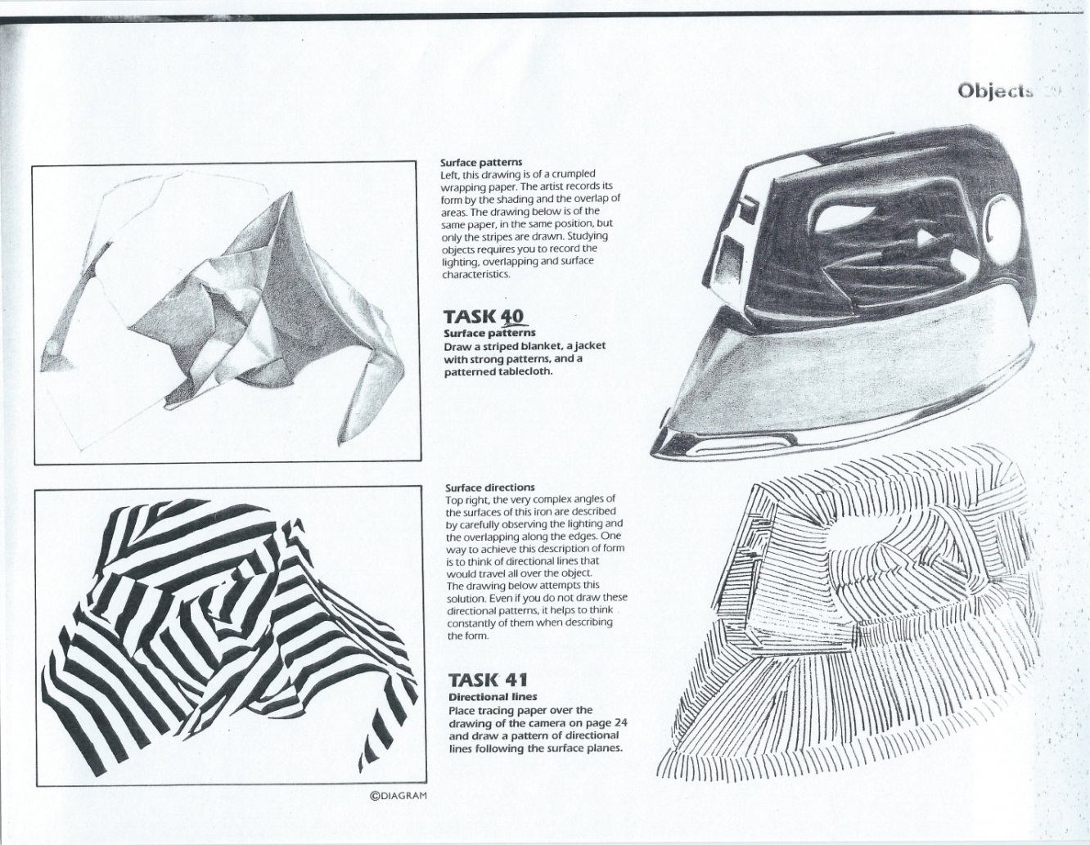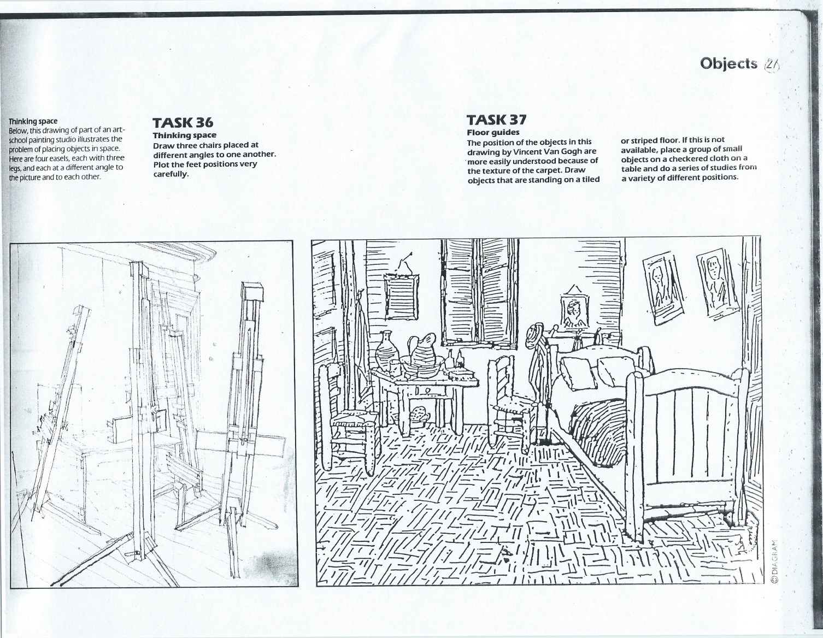

**Drawing & Painting Sketchbook Week** **10**- **Realistic Drawing** **vs**. **Mark Making**

Find two objects and draw it 1) realistically using shading and 2) using a line or dot pattern. (Options: stippling/dot patterns, cross hatching, diagonal lines, short straight line, etc.) **Complete** **4 total drawings**.

**Drawing & Painting Sketchbook Week** **10**- **Realistic Drawing** **vs**. **Mark Making**

Find two objects and draw it 1) realistically using shading and 2) using a line or dot pattern. (Options: stippling/dot patterns, cross hatching, diagonal lines, short straight line, etc.) **Complete** **4 total drawings**.