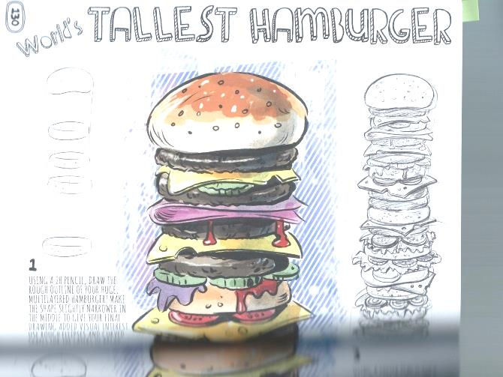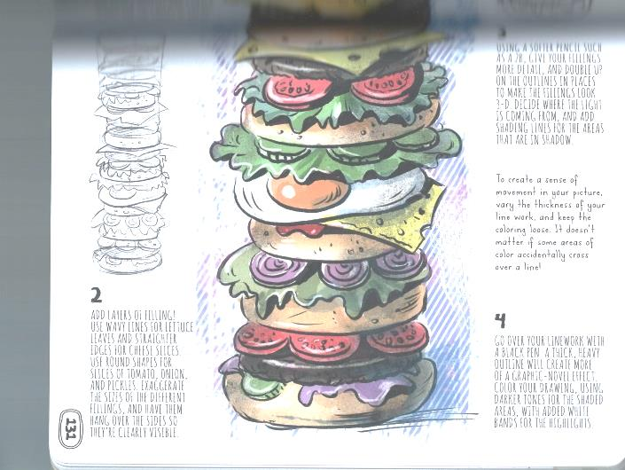

**Drawing & Painting Sketchbook Week 9- World’s Largest Due: __________**

Below is the World’s Tallest Hamburger. What can you invent? Draw your World’s Tallest or Largest Object showing the details of how it is the Tallest or Largest item. Add color if you wish. The image below is an example. Create one detailed drawing.

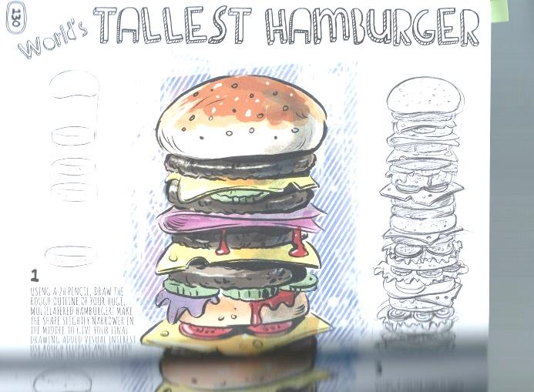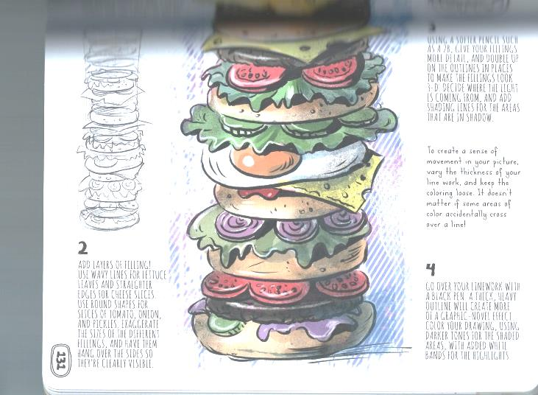

**Drawing & Painting Sketchbook Week 9- World’s Largest Due: __________**

Below is the World’s Tallest Hamburger. What can you invent? Draw your World’s Tallest or Largest Object showing the details of how it is the Tallest or Largest item. Add color if you wish. The image below is an example. Create one detailed drawing.