**Drawing & Painting Sketchbook Week 8- Landing & Falling Person Due: __________**

The person below is falling from somewhere and landing somewhere. In your sketchbook, invent and draw a place where they will fall or land and include the person in each drawing. Use your imagination! A total of 2 drawings are required.

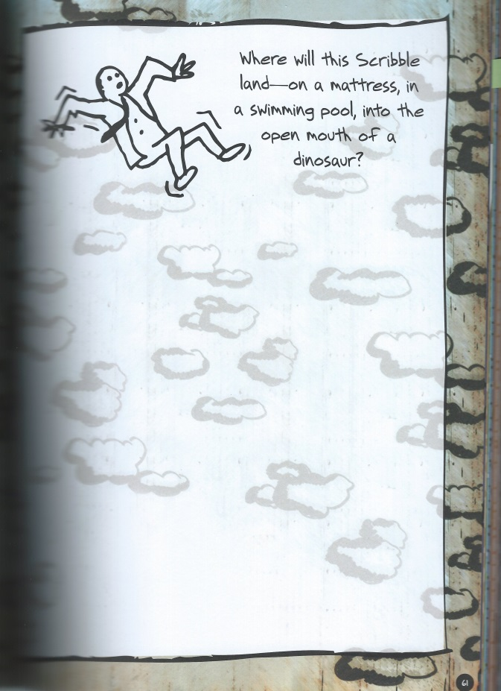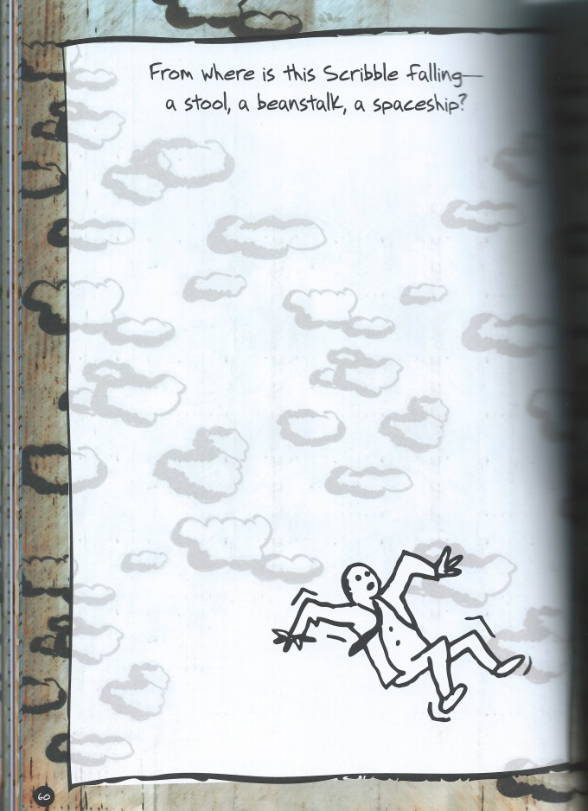

**Drawing & Painting Sketchbook Week 8- Landing & Falling Person Due: __________**

The person below is falling from somewhere and landing somewhere. In your sketchbook, invent and draw a place where they will fall or land and include the person in each drawing. Use your imagination! A total of 2 drawings are required.