**Drawing & Painting Sketchbook Week 7- Bodies Due: __________**

In your sketchbook, Re-draw the heads in your sketchbook and create five unique and imaginative bodies for the 5 creatures using a similar style like the head is drawn with. There is no requirement to the number of arms, legs, necks, etc for the creatures. A total of 5 drawings are required.

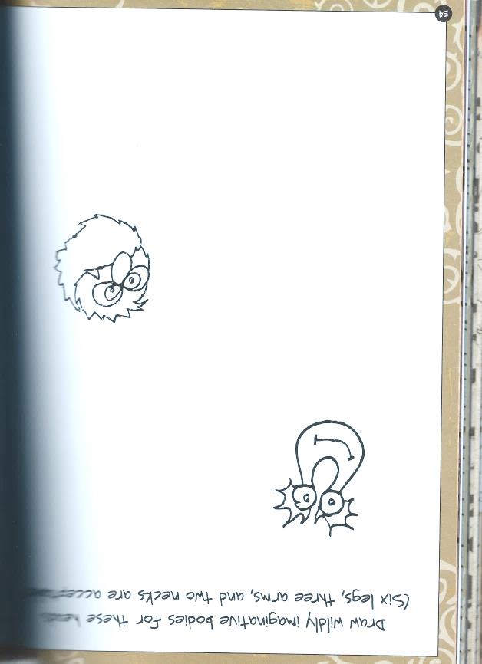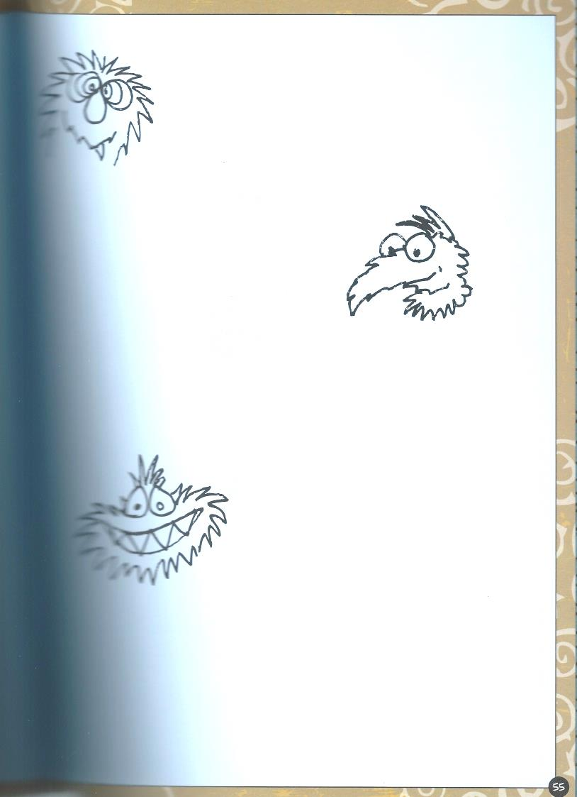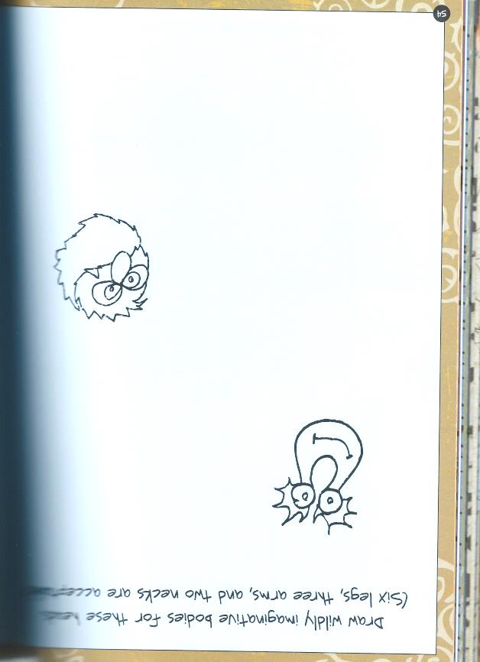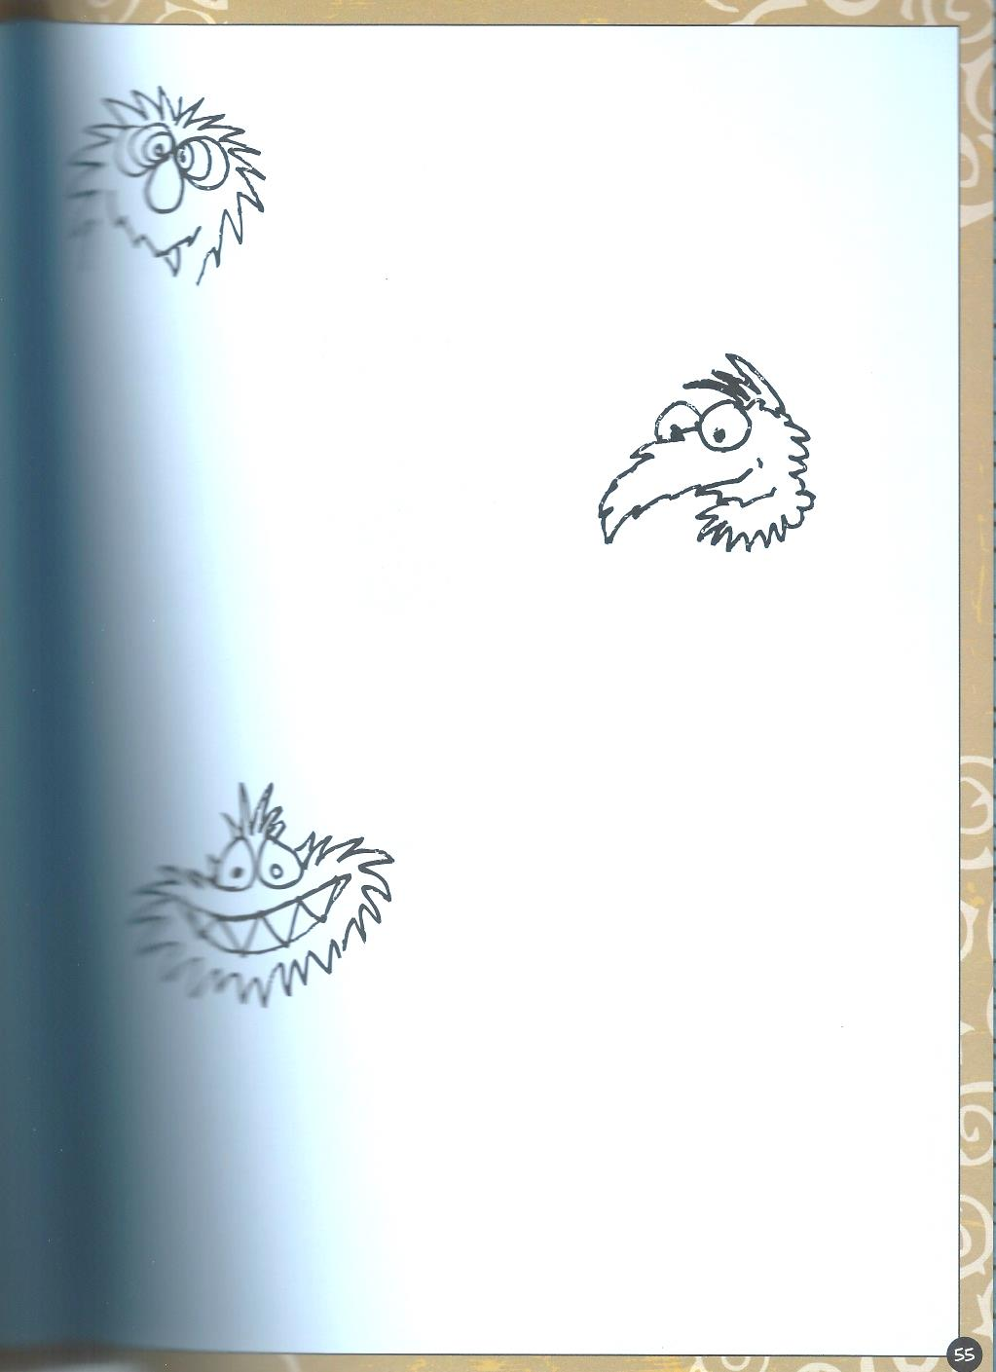

**Drawing & Painting Sketchbook Week 7- Bodies Due: __________**

In your sketchbook, Re-draw the heads in your sketchbook and create five unique and imaginative bodies for the 5 creatures using a similar style like the head is drawn with. There is no requirement to the number of arms, legs, necks, etc for the creatures. A total of 5 drawings are required.