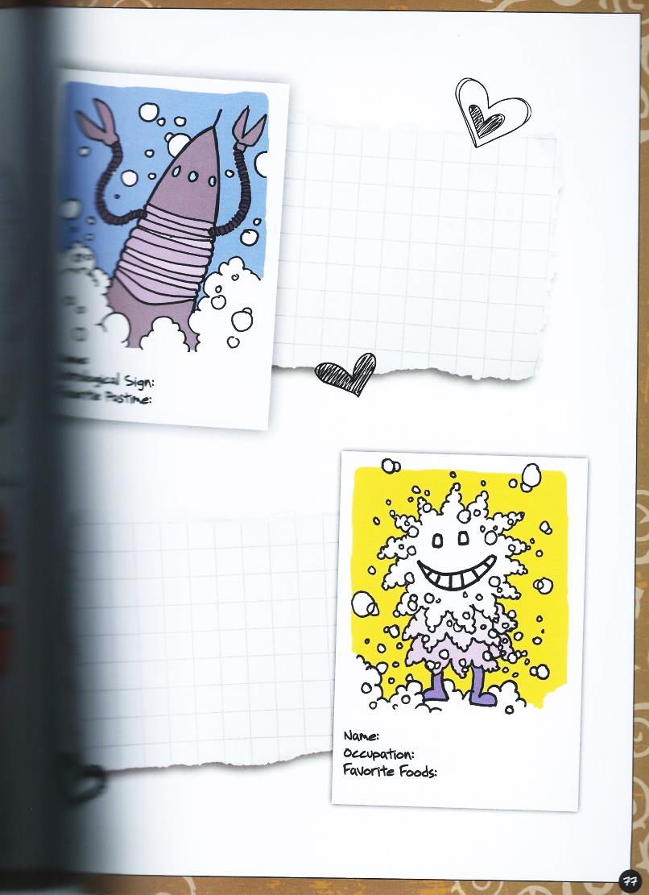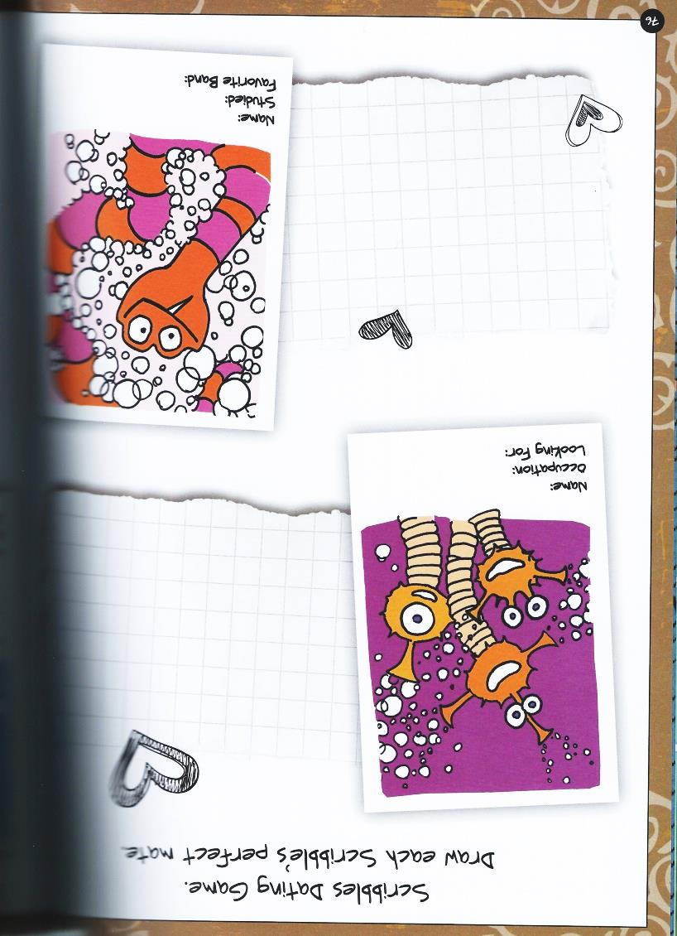

**Drawing & Painting Sketchbook Week 2- Perfect Date Due: __________**

In your sketchbook, draw 2 of the creatures below and create who their perfect date would be. Include details and facial features. A total of 4 drawings are required.



**Drawing & Painting Sketchbook Week 2- Perfect Date Due: __________**

In your sketchbook, draw 2 of the creatures below and create who their perfect date would be. Include details and facial features. A total of 4 drawings are required.