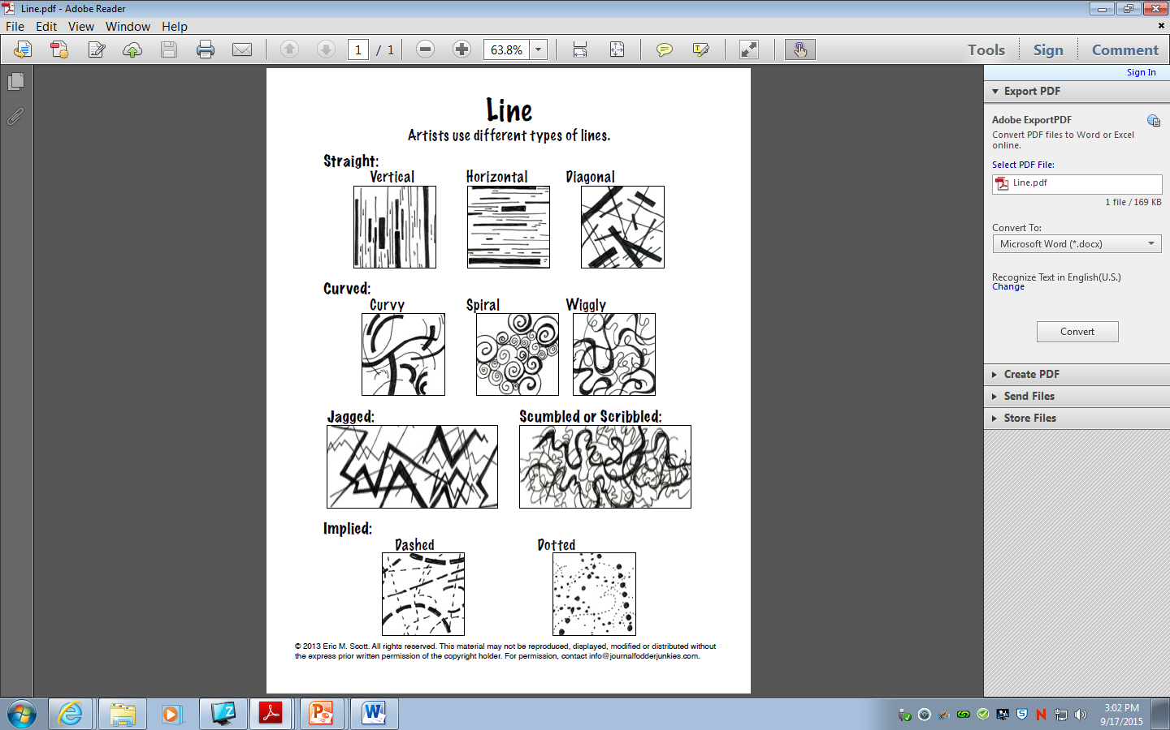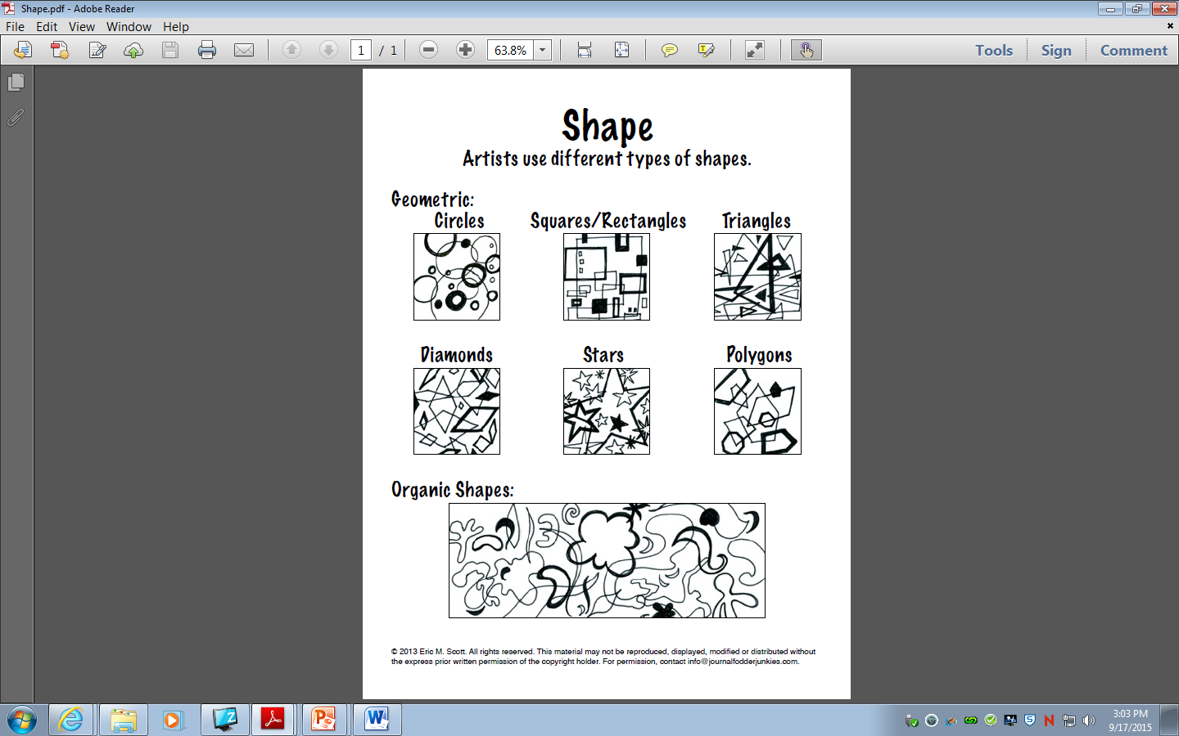

**Name_____________________________ Hr____**

**Name_____________________________ Hr____**

**Name_____________________________ Hr____**

**Name_____________________________ Hr____**

**Name_____________________________ Hr____**

**Name_____________________________ Hr____**

**Name_____________________________ Hr____**

**Name_____________________________ Hr____**

**Name_____________________________ Hr____**

**Name_____________________________ Hr____**

**Name_____________________________ Hr____**

**Name_____________________________ Hr____**

**Name_____________________________ Hr____**

**Name_____________________________ Hr____**

**Name_____________________________ Hr____**

**Name_____________________________ Hr____**

**Name_____________________________ Hr____**

**Name_____________________________ Hr____**

**Name_____________________________ Hr____**

**Name_____________________________ Hr____**

**Name_____________________________ Hr____**

**Name_____________________________ Hr____**

**Name_____________________________ Hr____**

**Name_____________________________ Hr____**

**Name_____________________________ Hr____**

**Name_____________________________ Hr____**

**Name_____________________________ Hr____**

**Name_____________________________ Hr____**

**Name_____________________________ Hr____**

Use pencil to create your own line and shape designs using the type of line or shape indicated on the left. Use thin and thick lines, layering, overlapping and scale (change in size).

**Name_____________________________ Hr____**

**Name_____________________________ Hr____**

**Name_____________________________ Hr____**

**Name_____________________________ Hr____**

**Name_____________________________ Hr____**

**Name_____________________________ Hr____**

**Designs using Line & Shape**