**[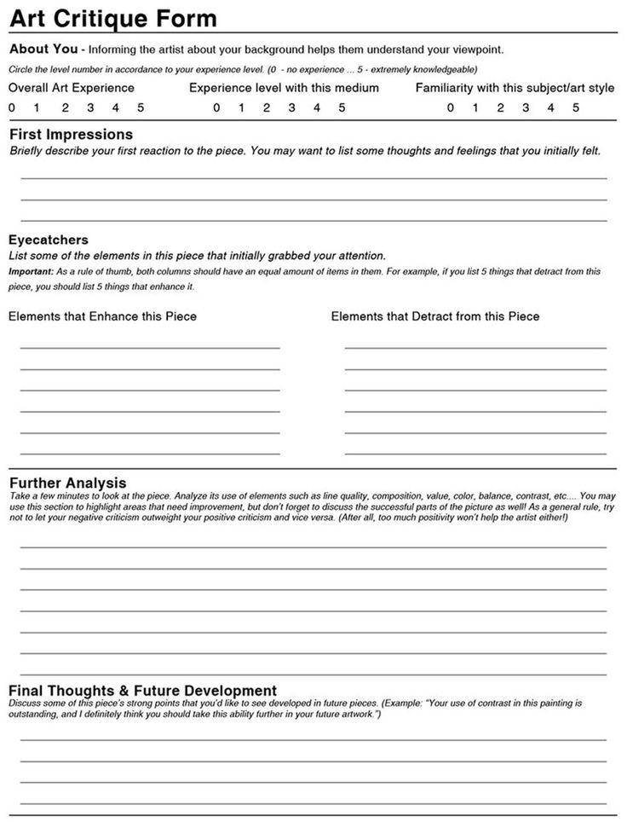](http://www.shelbyed.k12.al.us/schools/mhs/faculty/hwhitson/Art-new/Critique%20handout.jpg)**