**[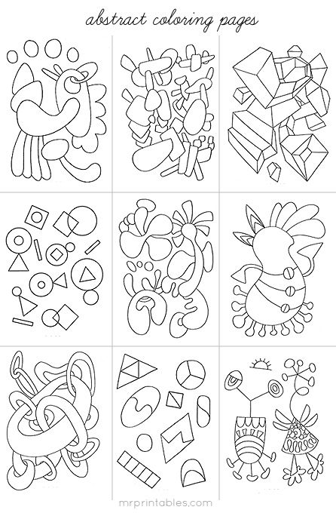](http://www.mrprintables.com/abstract-coloring-pages.html)**