[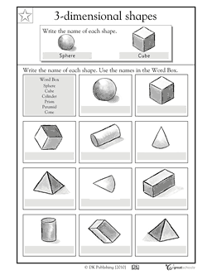](http://www.gscdn.org/library/cms/91/10291.pdf)