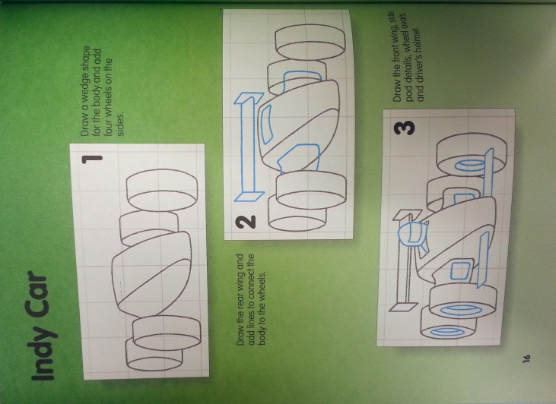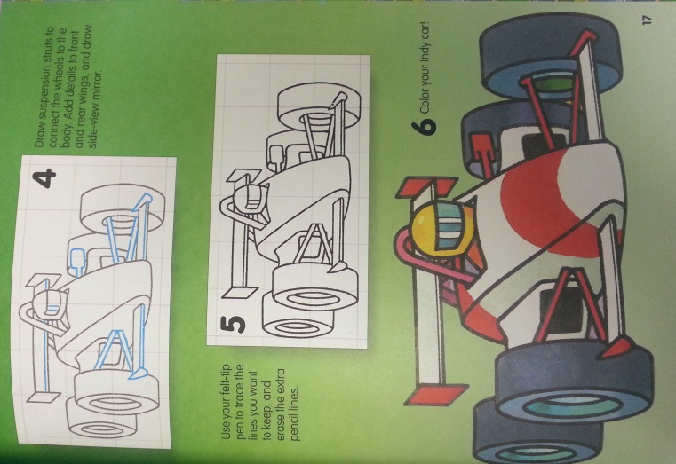

**Wk. 9 Sketches**- Draw the indy car and add shading to make it look realistic. You do not need to add color.

**Wk. 9 Sketches**- Draw the indy car and add shading to make it look realistic. You do not need to add color.