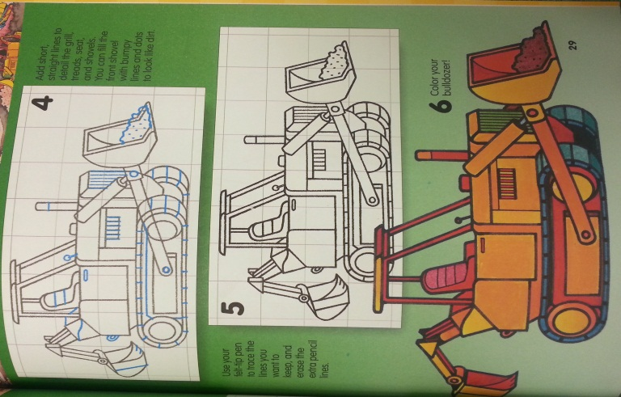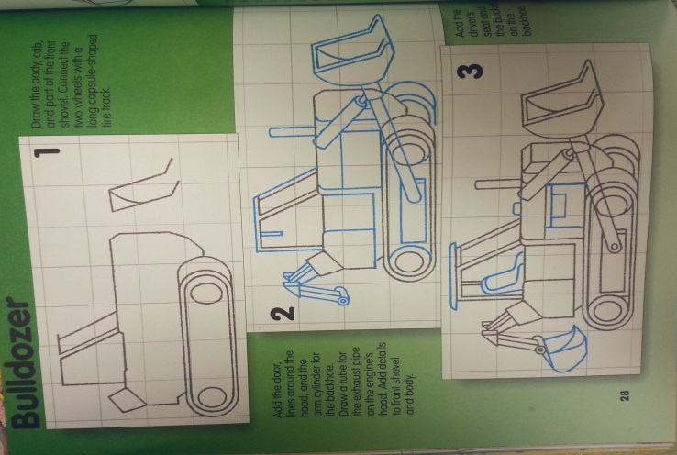

**Wk. 8 Sketches**- Draw the bulldozer and add shading to make it look realistic. You do not need to add color.

**Wk. 8 Sketches**- Draw the bulldozer and add shading to make it look realistic. You do not need to add color.