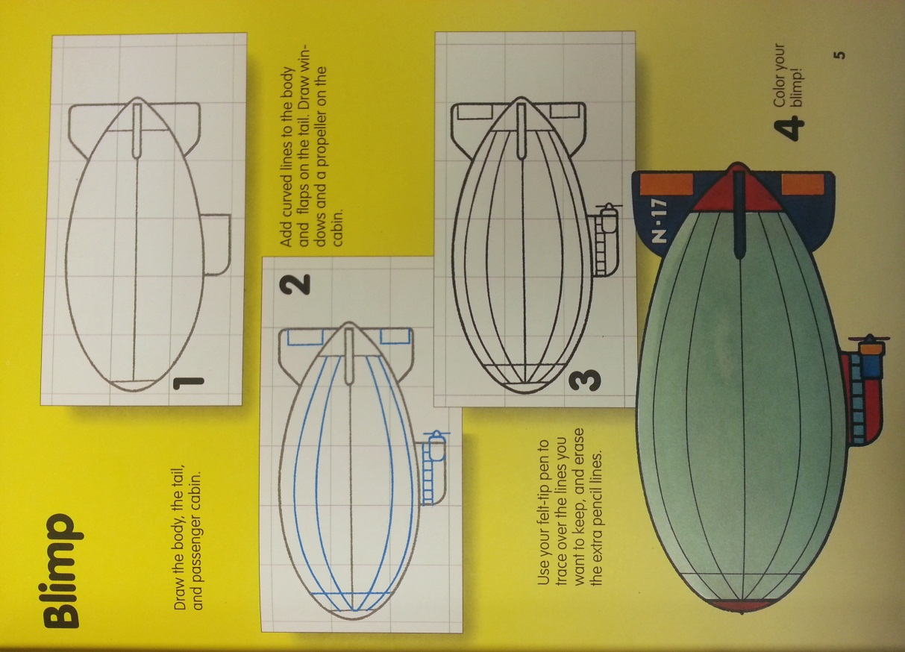

**Wk. 7 Sketches**- Draw the blimp and add shading to make it look realistic. You do not need to add color.

**Wk. 7 Sketches**- Draw the blimp and add shading to make it look realistic. You do not need to add color.