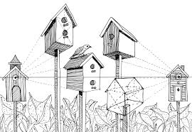

**Wk. 12 Sketches**- Draw 4 of the birdhouses and add shading lines to make it look realistic. You do not need to add color. Then draw your own style of birdhouse (1).

**Wk. 12 Sketches**- Draw 4 of the birdhouses and add shading lines to make it look realistic. You do not need to add color. Then draw your own style of birdhouse (1).