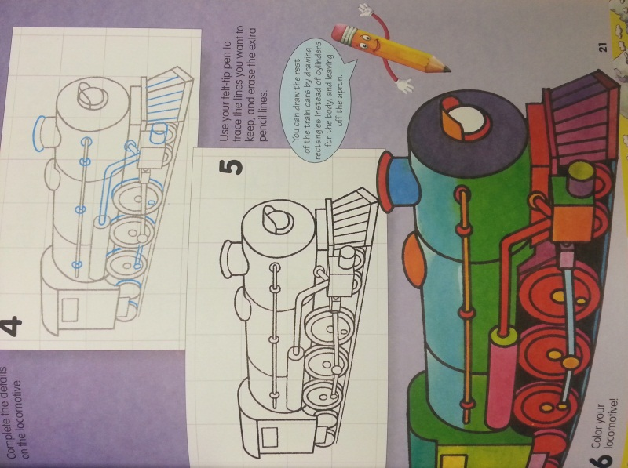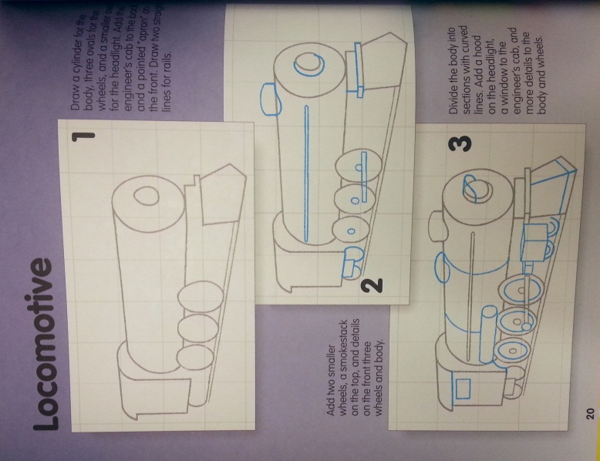

**Wk. 10 Sketches**- Draw the locomotive and add shading to make it look realistic. You do not need to add color.

**Wk. 10 Sketches**- Draw the locomotive and add shading to make it look realistic. You do not need to add color.