Visual Journal Resources (list courtesy of Journal Fodder Junkies- Eric Scott & David Modler)

Artist Books

Leonardo da Vinci
- The Notebooks of Leonardo da Vinci by Jean Paul Richter
- Leonardo da Vinci: Sketches and Drawings by Frank Zöllner
Frida Kahlo
- The Diary of Frida Kahlo
Dan Eldon
- The Journey is the Destination: The Journals of Dan Eldon by Kathy Eldon
- Dan Eldon: The Art of Life by Jennifer New

Sabrina Ward Harrison
- Spilling Open: The Art of Becoming Yourself
- Brave on the Rocks: If You Don’t Go, You Don’t See
- Messy Thrilling Life: The Art of Figuring Out How to Live

Books on Journals and Techniques
The Journal Junkies Workshop: Visual Ammunition for the Art Addict by Eric M. Scott and David R. Modler
Artists’ Journals and Sketchbooks: Exploring and Creating Personal Pages by Lynne Perrella
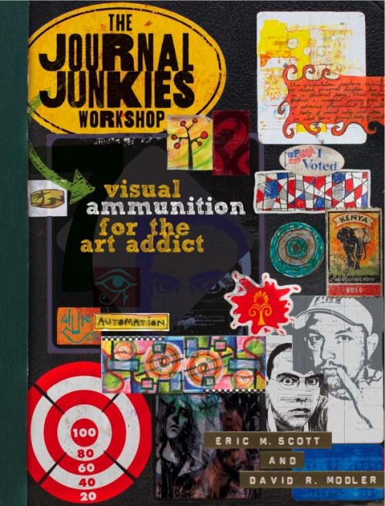
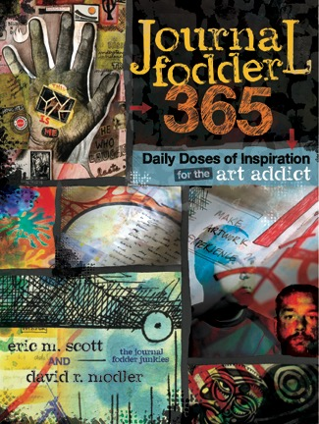
Drawing From Life: The Journal as Art by Jennifer New
The Decorated Page by Gwen Diehn
The Decorated Journal by Gwen Diehn
Celebrate Your Creative Self by Mary Todd Beam
The Artist’s Way by Julia Cameron
The Creative Artist by Nita Leland
Experimental Drawing by Robert Kaupelis
Visual Journaling: Going Deeper Than Words by Barbara Ganim

Miscellaneous Books
Symbol Sourcebook: An Authoritative Guide to International Graphic Symbols by Henry Dreyfuss
Signs of Life: The Five Universal Shapes and How to Use Them by Angeles Arrien

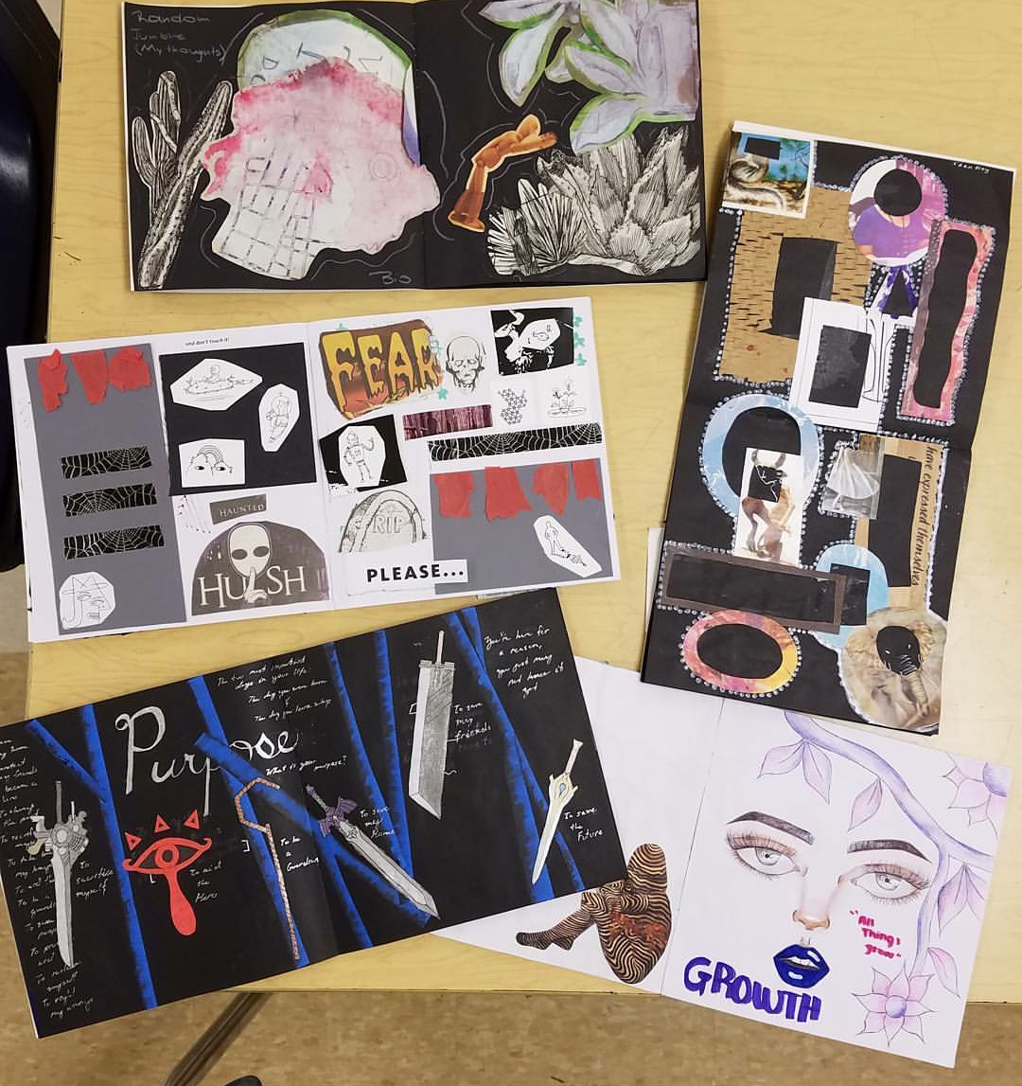
Web Sites

www.journalfodderjunkies.com
www.journalfodderjunkies.blogspot.com
www.daneldon.org
www.sketchbob.com
www.teeshamoore.com
www.johncopeland.com
www.zettiology.com
www.1000journals.com
www.1001journals.com
www.visualjournaling.com
www.busywomen.com (14 reasons to keep a journal)
www.kporterfield.com
http://jeffcoweb.jeffco.k12.co.us/isu/art/sketchbook.html
Jennifer Kay-Rivera
Visual Journals
in the Art Education Classroom
Implementation & Collaborative Projects
Warren Consolidated Schools
www.jkay-rivera.weebly.com
jrivera@wcskids.net
@stallionartists

What is a Visual Journal? Visual Journal vs. Sketchbook vs. Journal
Sketchbook? Scrapbook? Art Journal? Interactive Notebook? Smash Book? Visual Diary?

Uses for a Visual Journal
Documentation, Process, Inspiration, Practice Skills, Share Experiences, Self-expression, Sketch Notes, Meditation, Writing, Bell Ringer/Warm-Ups

Implementation
- Rotate through Stations/Centers, focus on specific skills
- Could be a way to begin TAB or incorporate Studio Thinking Strategies
- Teach new media in small doses, no need for a 2 week project
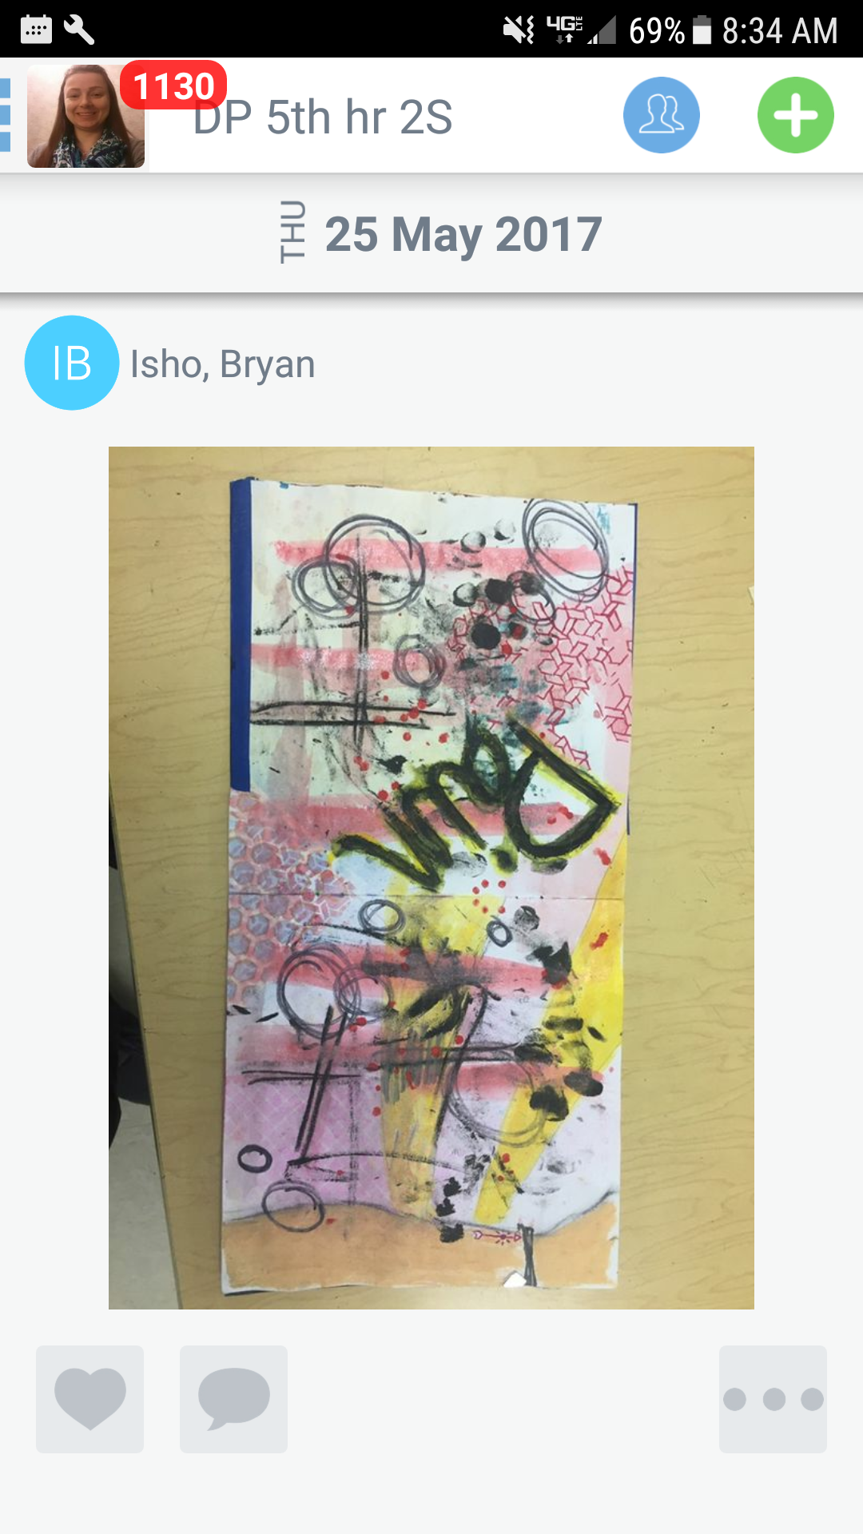
- Independent art making
- Collaborative learning
- Low pressure environment, encourages Growth Mindset
- Experimentation- “Art Lab”

“Seesaw” Digital Portfolio
  - app is setup like Facebook feed
  - teacher is admin, has control of settings
  - students upload photos/videos of journal pages
  - documenting process
  - peer feedback (likes, comments, inquiry)
  - possible evaluation tool
  - Private app for class, may share link with parents

Journal Exchange
  - 1:1 exchange, Round Robin exchange, school exchange
  - Must have collective commitments from all participants
  - Teachers need to set specific exchange schedule & criteria for success
  - We used JFJ’s Big Ideas as themes, each student chose 8 themes

Possible Supplies for Centers
- Stencils- various letter fonts, shapes, Spirograph, ruler
- Watercolor- sprays, pencils, paint, WC markers, water bottle
- Writing/Drawing Supplies- pens, sharpies, metallic markers, crayons, color sticks,
color pencils, drawing pencils, etc.
- Fodder- various images from brochures, postcards, maps, stickers
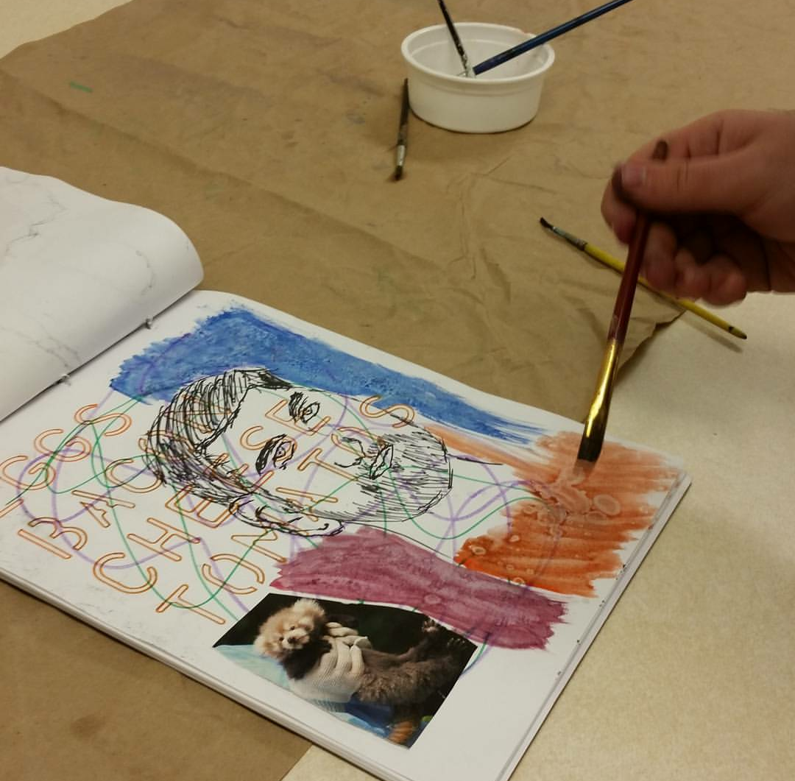
- Paint- acrylic, paint pens, gesso, paint sticks, antiquing paint, brushes
- Paper- scrapbook paper plain/pattern, cardstock
- Cutting Tools- scissors, x-acto knife & mat, deckled edge scissors
- Textures- rubbing/embossing plates, found objects
- Adhesives- liquid glue, glue stick, washi tape, matte medium
- Stamps- letters, stamp pads, gelli plates, carved print blocks

