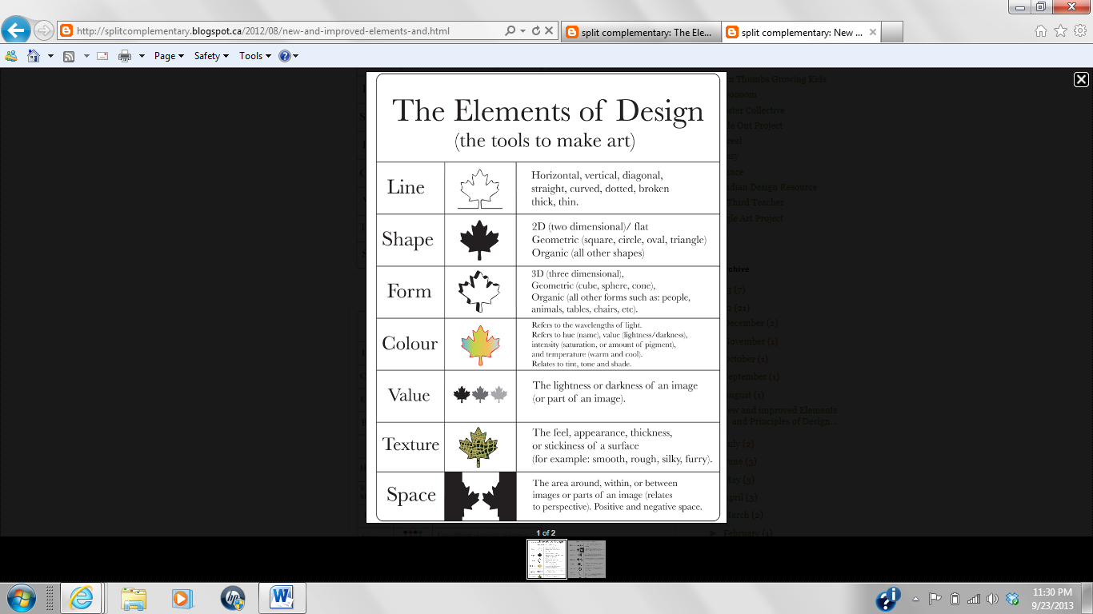

Name ___________________________ Hr ___

Color

**Line**- A mark created by a tool, suggests movement (horizontal, vertical, diagonal, straight, curved, dotted, broken, thick, thin)

**Shape**- A contained area that has length and width (2D- two dimensional/flat, Geometric - square, circle, oval, triangle, Organic- all other natural shapes)

**Form**- The 3D aspects of objects that take up space. (3D- three dimensional, Geometric- cube, square, cone, Organic- all other forms: people, animals, tables, etc.)

**Color**- Light must be present to see this

(refers to wavelengths of light. Hue is the name of the color. Value is lightness/darkness)

**Value**- Light must be present to see this

(lightness of darkness of an image)

**Texture**- Surface quality of artwork

(the feel, appearance, thickness, of a surface- rough, smooth, sticky, silky, furry)

**Space**- 3-Dimensional volume, illusion of depth (the area around, within or between images or parts of an image, relates to perspective)

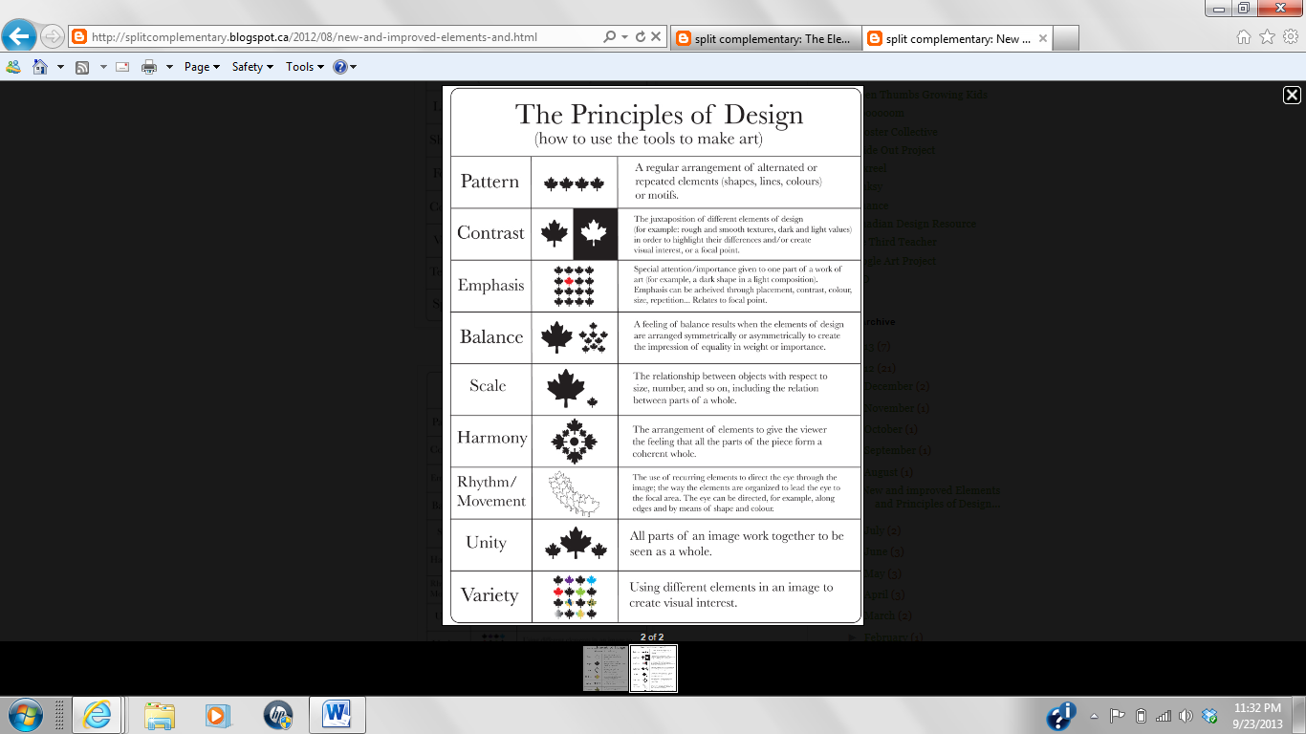

**Pattern**- Uses art elements in repetitive designs(regular, alternated or repeated pattern using line, shape, colors or design)

**Contrast**- The difference in value, color, shape, etc (use of opposites to create visual interest or focal point)

**Emphasis**- Creates dominance and focus in art (special attention/importance to a certain part of the artwork)

**Balance**- Distribution of visual weight in art (symmetrical, asymmetrical)

**Scale**- the change in size of the object, including different sized parts, small, medium and large. (relationship between objects in regards to size, number, etc)

**Harmony-** the parts working together to enhance the overall look, harmoniously (all the parts go together to create the whole image)

**Rhythm**- Repetition of visual movement (recurring elements, creates a visual “beat” or pattern for the eye)

**Movement**- Helpful in creating a focal point, directs your eye (how your eye is drawn/directed throughout the artwork)

**Unity**- The cohesive quality of artwork to feel finished (all parts working together in the image)

**Variety**- several elements or principles present in an artwork to create an overall look (different elements to create visual interest)