Jennifer Kay-Rivera
Mark-Making
String Ink Painting & Chalk Pastels
Warren Consolidated Schools
www.jkay-rivera.weebly.com
jrivera@wcskids.net

Objective: To use string and India ink to create unique and diverse marks relating to line and line quality.

Time Frame: 1-2 weeks depending on how many components of this lesson are completed.
Part 1- Days 1 & 2 Part 2- Days 3-5 Part 3- Days 6-14 Based on a 60 min class session

Materials:
Part 1- bottle of black India Ink, small cups for ink (must be able to dip string into), cotton string (I prefer 2oz weight, Peaches & Cream brand), white drawing paper 11x17 or larger (3-4 sheets per student), newspaper to cover tables
Part 2- chalk pastels, pastel pencils or nu pastels, kneaded erasers, newspaper to cover tables
Alternative media option- colored pencils, oil pastels, art sticks (barrel-less colored pencils)
Part 3- x-acto knife, cutting mat, view finder, square template, glue stick or liquid glue, larger paper to attach squares to, ruler, pencil

Project Directions:
Part 1- Students will use string as the paintbrush to create a dynamic art piece. Dip the string in ink, do not submerse. Drag or drop the inked string on and across the paper to create marks using different motions. The string could be looped, tied in a knot or bow, folded, frayed, etc. and then dipped in ink to achieve a different mark. Instrumental music can be played to add an additional sensory component. Discourage students from making specific recognizable shapes and focus on lines and line quality. Create 2 paintings each day in order work out technique and have options for the final project.

Part 2- select the best 2 ink paintings and a limited color palette of 3-4 colors. Add color media to enhance and accent ink designs. The color should be added in the white space and should not necessarily fill all the white space. One of these will remain whole, the other will be used in part 3.

Part 3- [Optional- Select one of the two colored ink artworks to be cut apart. Use a view finder to locate interesting sections and trace a 2”x2” or 3”x”3” square template on that area. Find 12 squares in the artwork. Use the x-acto knife to cut them out. Arrange the 12 squares to make a 2x6 square grid or a 3x4 square grid so that the colors and lines flow across the edges of each piece into the next square to create good movement and unity.] Students will rework the squares to add more color or shading as needed to create a balanced composition for each square to be assembled with the group.

Part 1: String Painting w/Ink Part 2: Add colored media
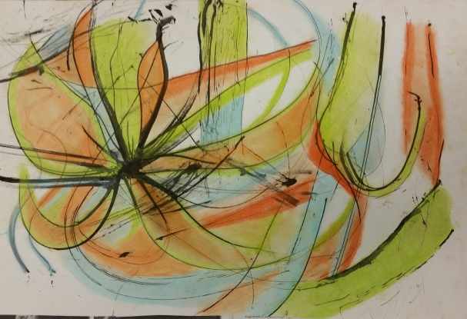

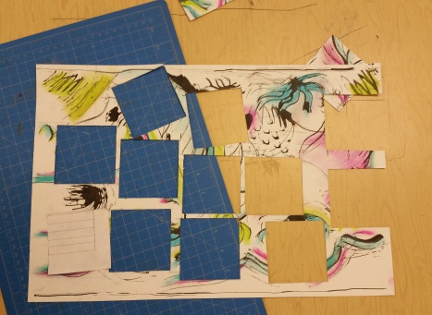
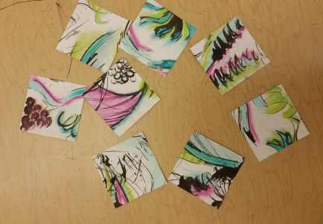
Part 3: Use view finder to cut squares, rework the mini compositions

Part 4: Assemble Tiles, Glue to Paper
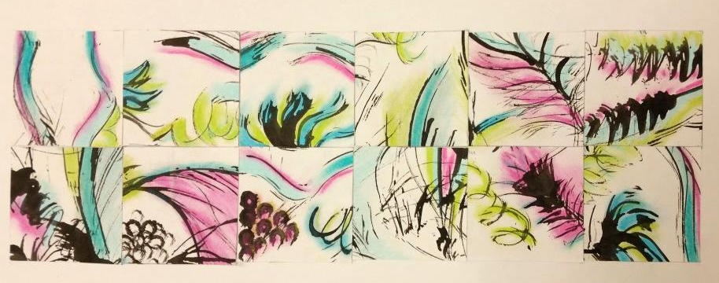

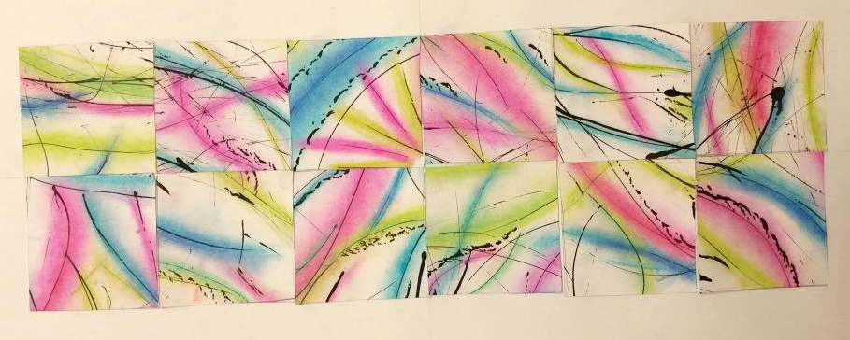

2x6 Grid Finished Piece 4x3 Grid Finished Piece

