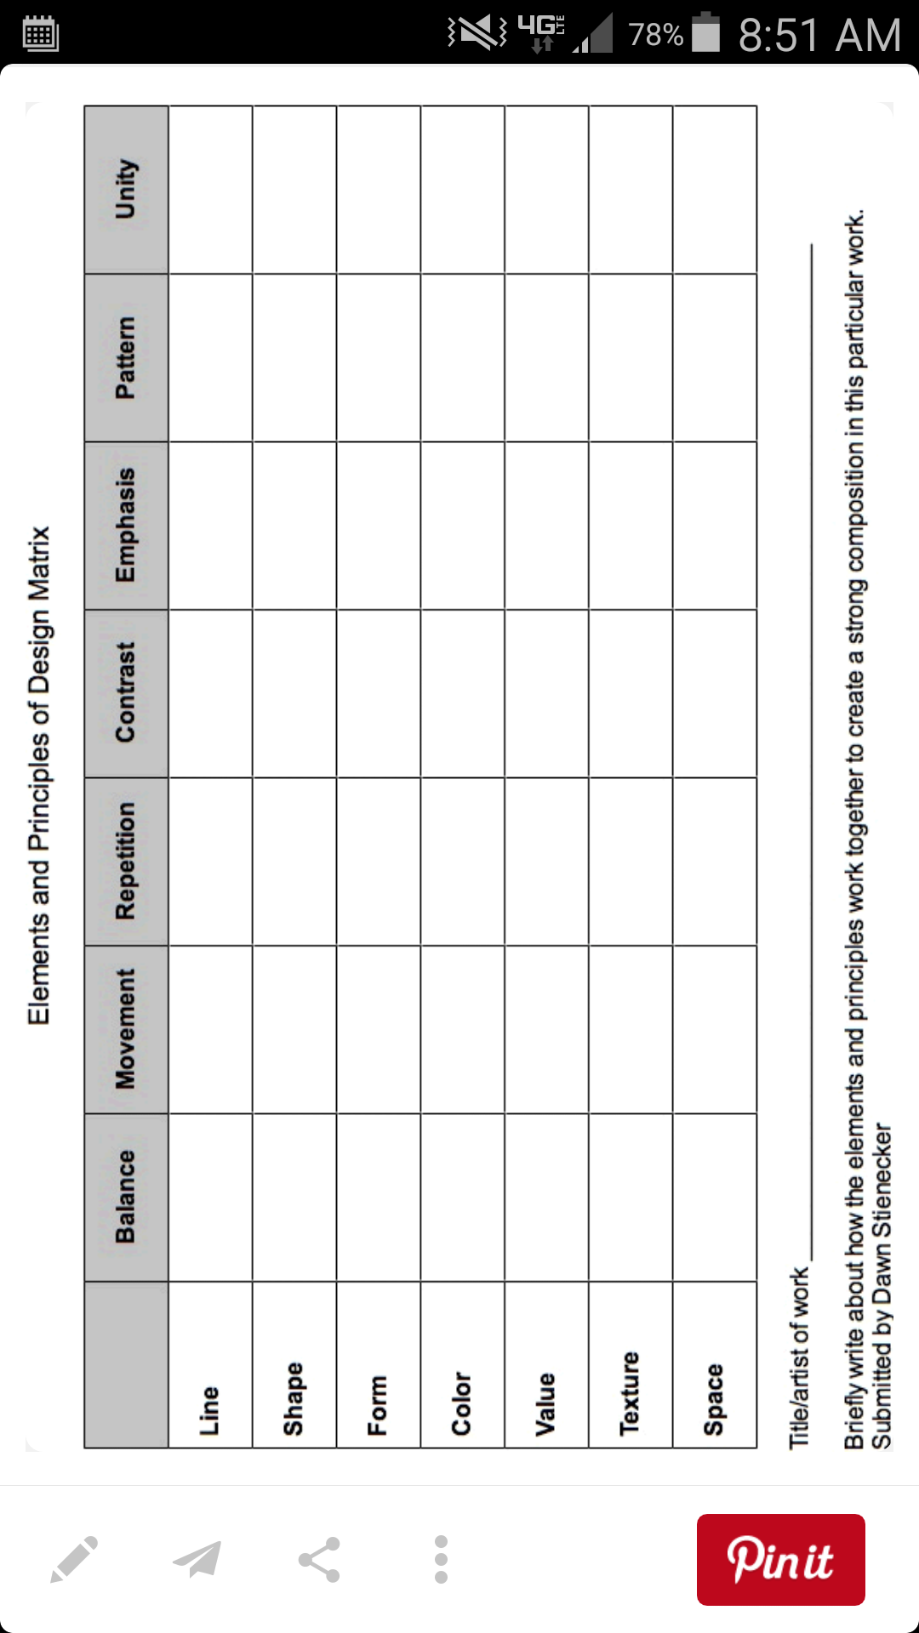Name_________________________________ Hr___

Create a design that combines the word on the top row and side column for each box.

