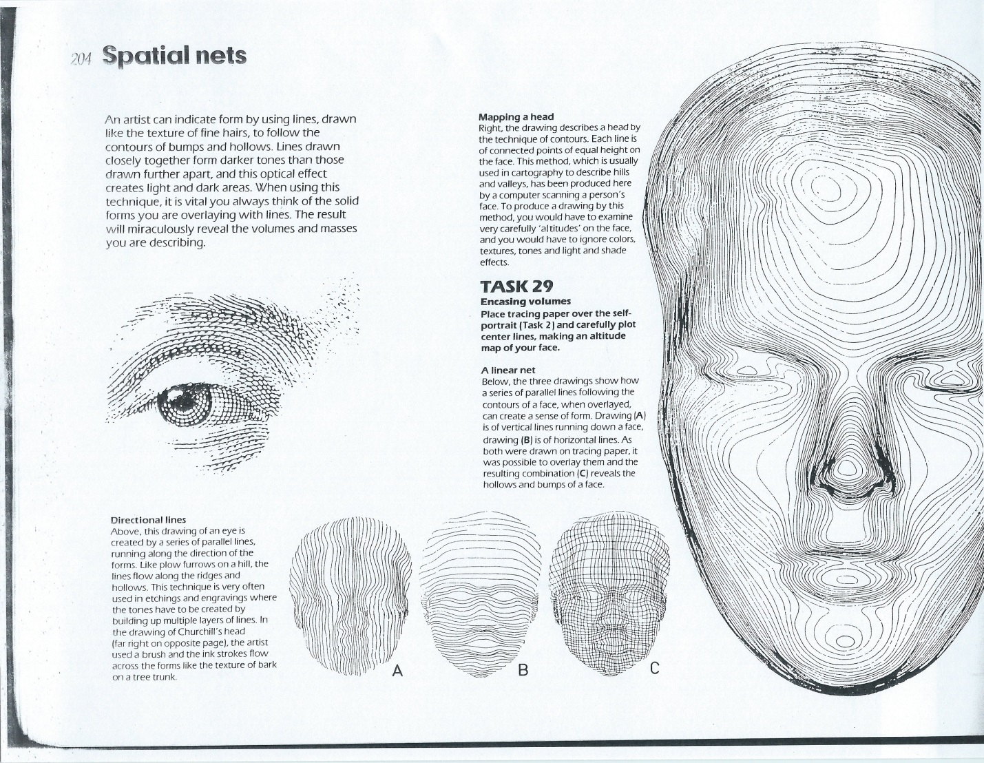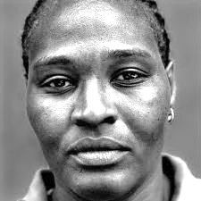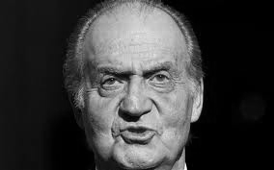

**Drawing & Painting Sketchbook Week 5- Spatial Nets for Facial Features on People**

Draw one of the people below using the three spatial net techniques in pictures A, B and C

**Drawing & Painting Sketchbook Week 5- Spatial Nets for Facial Features on People**

Draw one of the people below using the three spatial net techniques in pictures A, B and C

**Drawing & Painting**

**Sketchbook Week 5- Spatial Nets for Drawing People**

Draw a person (in real life or from a photo) using the spatial net techniques in pictures A, B, C