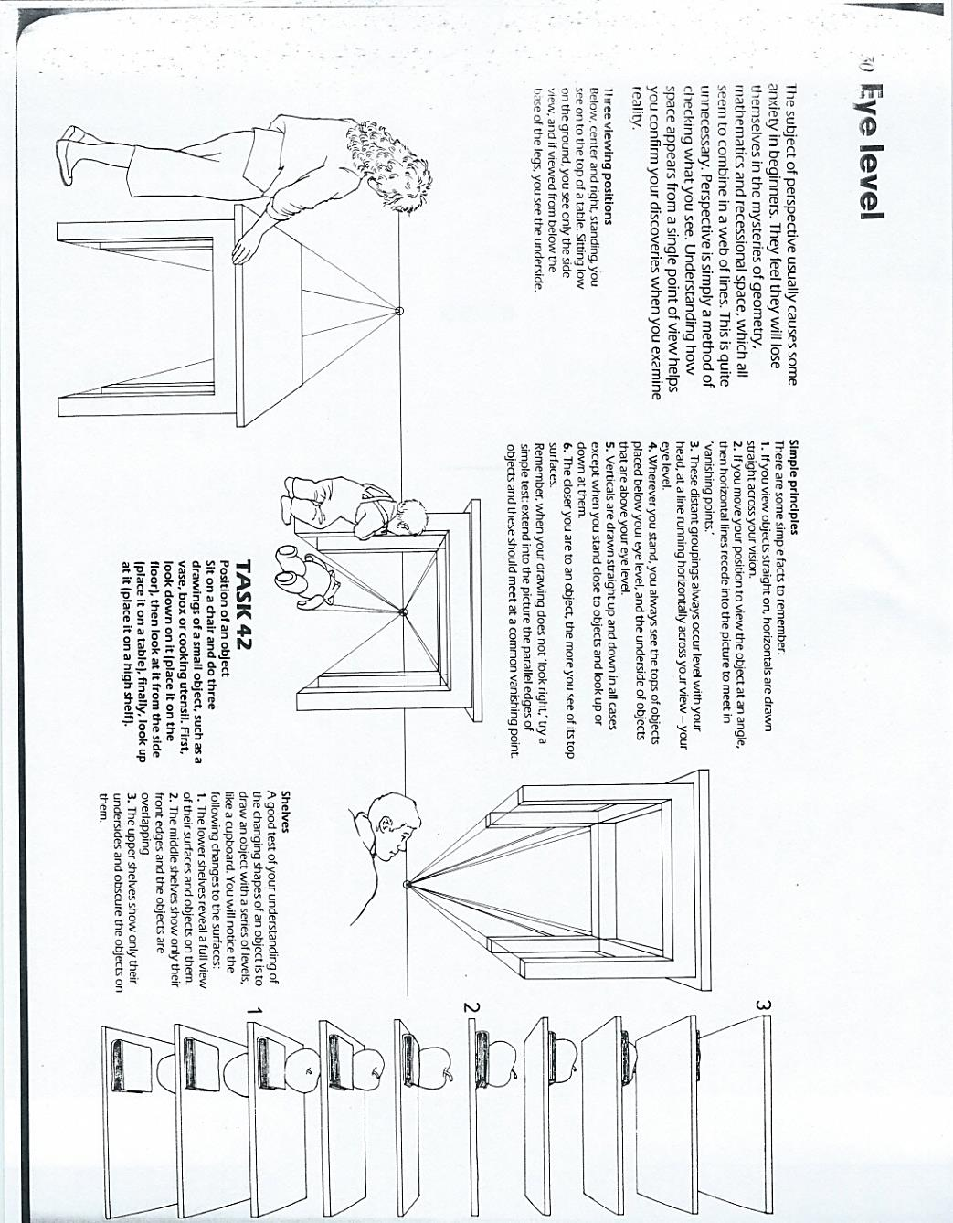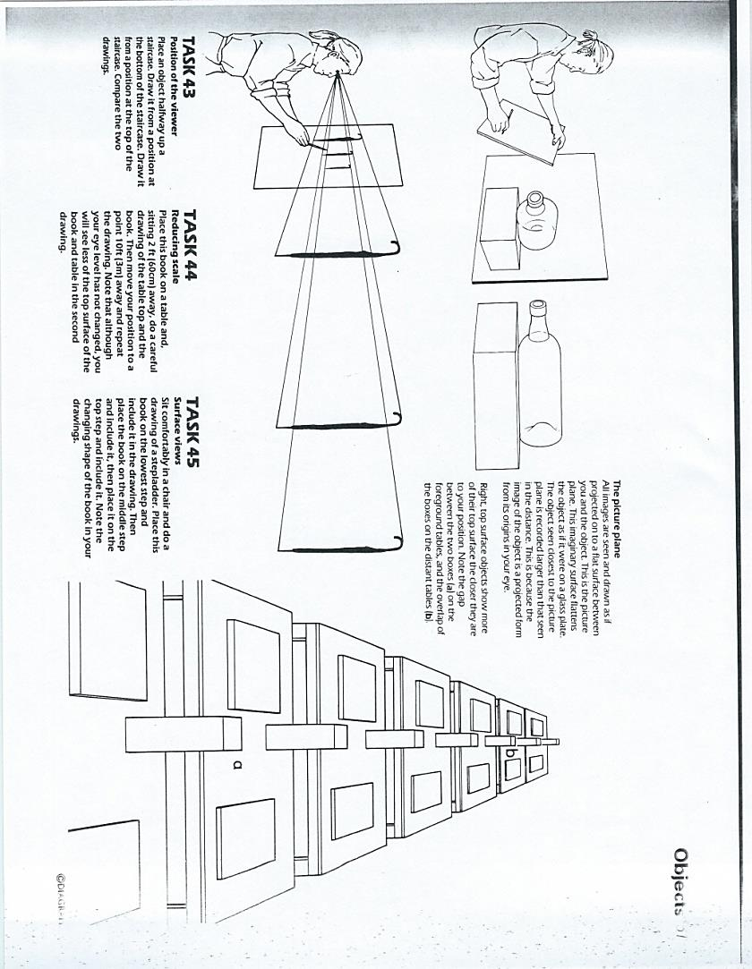

**Drawing & Painting Sketchbook Week 2 -Views of 1pt Perspective**

Create the drawing on the far right of **the top** picture. Draw the three

pictures on the bottom. All drawings use 1 pt perspective.

**Drawing & Painting Sketchbook Week 2 -Views of 1pt Perspective**

Create the drawing on the far right of **the top** picture. Draw the three

pictures on the bottom. All drawings use 1 pt perspective.

