**Drawing & Painting Sketchbook Week** **9** – **Finding Shapes- Positive & Negative Space**

Use the images on the right. Draw the images to find/create the contour or outside edges of all objects in the image. Then darken those parts of the image like the examples to create positive negative space. The empty space is negative space, the solid parts of the image are the positive.

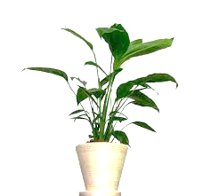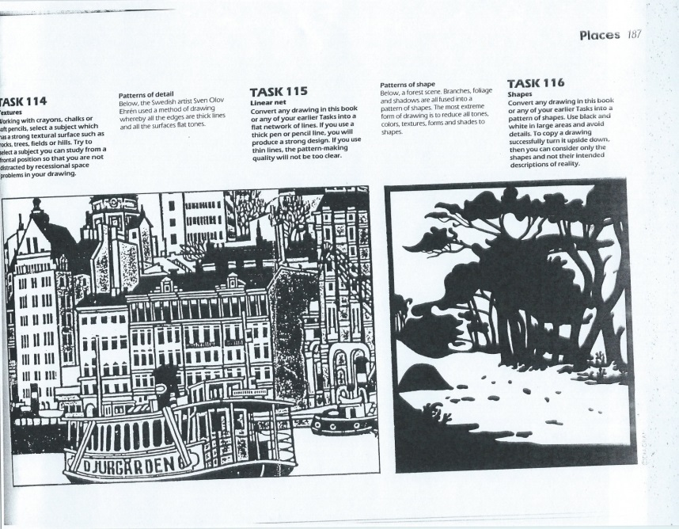Example Draw the plant & tree

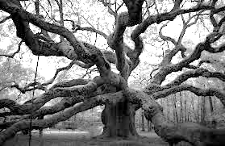

**Drawing & Painting Sketchbook Week 9** - **Finding Shapes- Positive & Negative Space**

Use the images on the right. Draw the images to find/create the contour or outside edges of all objects in the image. Then darken those parts of the image like the examples to create positive negative space. The empty space is negative space, the solid parts of the image are the positive.

Example Draw the plant & tree