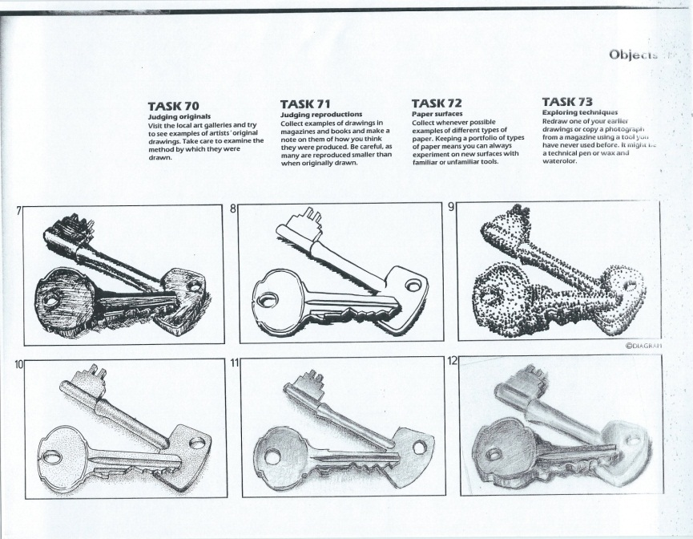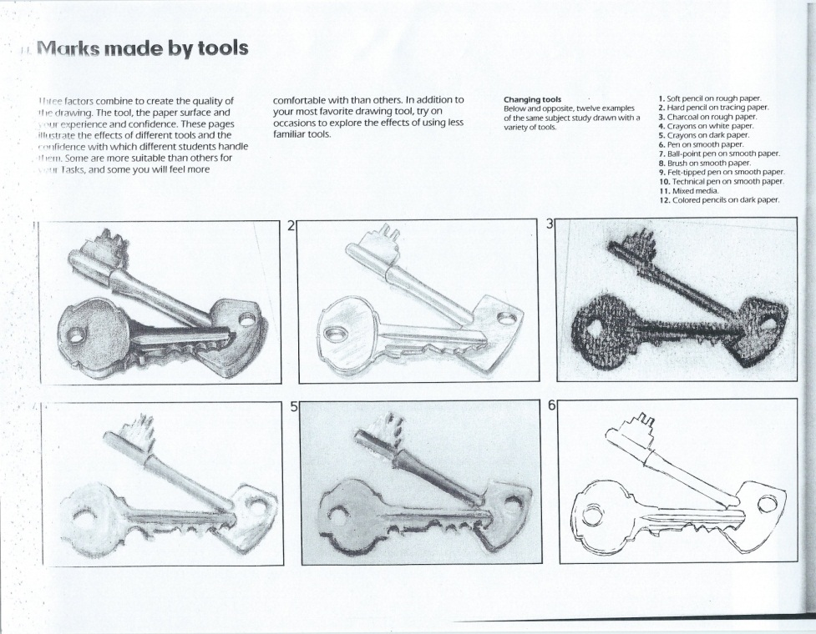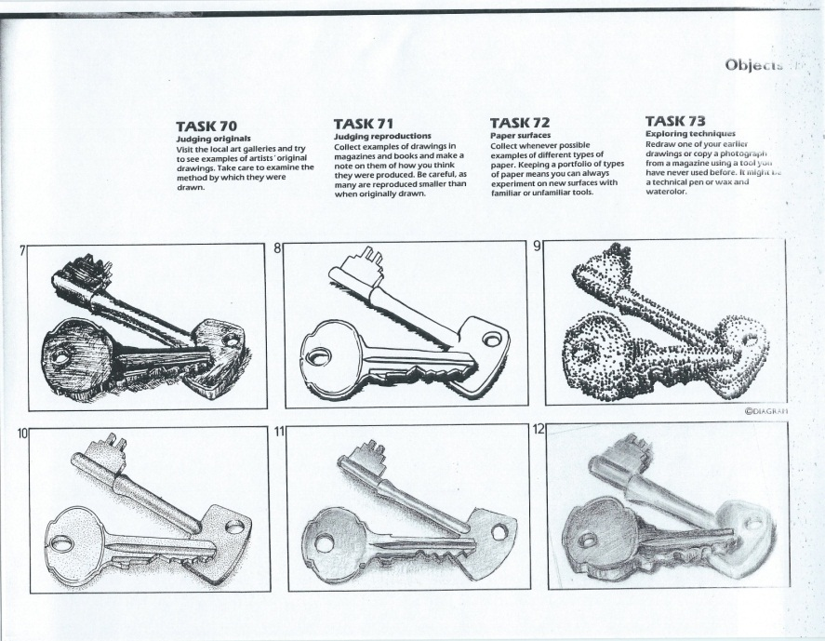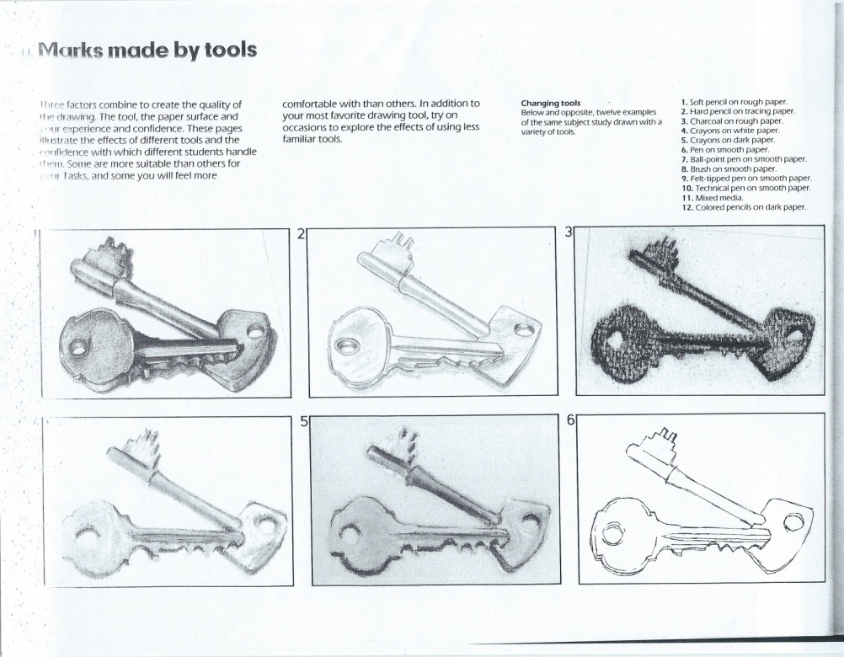

**Drawing & Painting Sketchbook Week** **8**- **Mark Making**

Find an object and redraw it 5 times using 1) different types of line, 2) stippling or dot patterns 3) cross hatching, 4) diagonal lines 5) short straight line to create the object. Examples of the drawing types are below.

**Drawing & Painting Sketchbook Week** **8**- **Mark Making**

Find an object and redraw it 5 times using 1) different types of line, 2) stippling or dot patterns 3) cross hatching, 4) diagonal lines 5) short straight line to create the object. Examples of the drawing types are below.