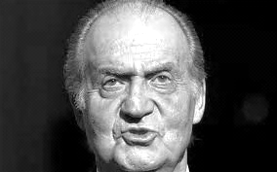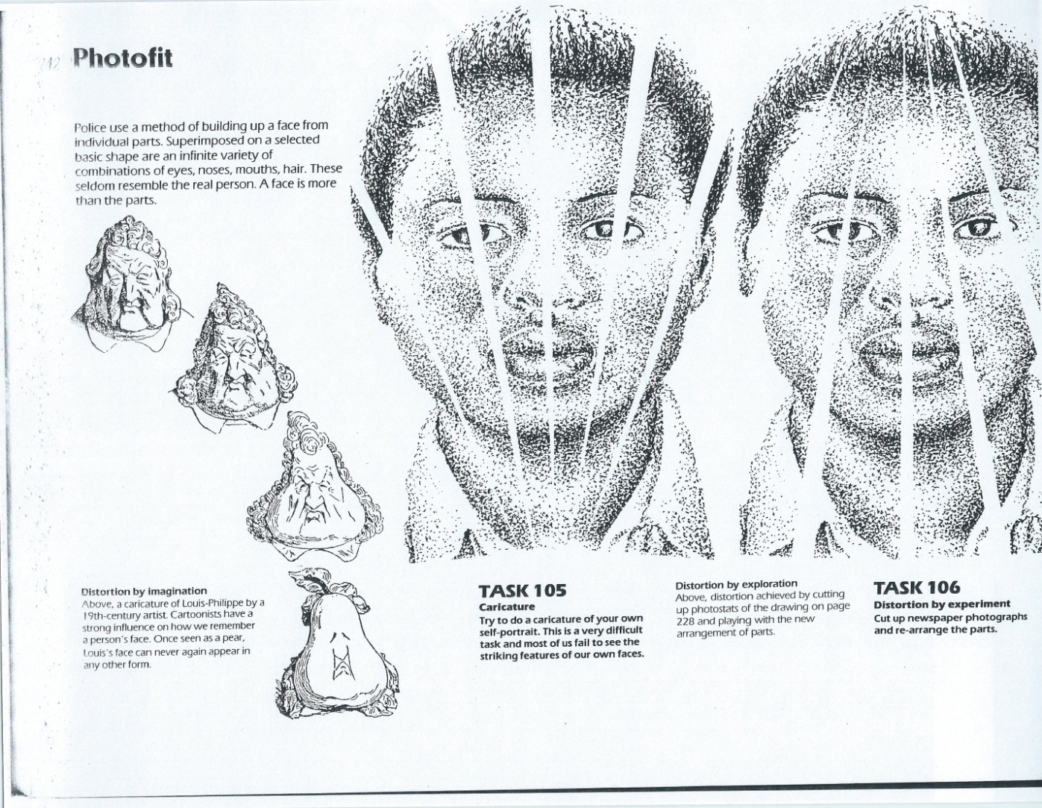

**Drawing & Painting Sketchbook Week 6- Distorting Portraits with Photo Fit**

Use the photo below or print a photo of a person, cut it apart in 3-5 parts like the example using the distortion technique below. Then draw in the missing parts of the. photo to match that section of the face.

**Drawing & Painting Sketchbook Week 6- Distorting Portraits with Photo Fit**

Use the photo below or print a photo of a person, cut it apart in 3-5 parts like the example using the distortion technique below. Then draw in the missing parts of the. photo to match that section of the face.

**Drawing & Painting Sketchbook Week 6- Drawing People with Distortion**

Print a photo of a person, cut it apart in 3 -5 parts like the example using the distortion technique below.