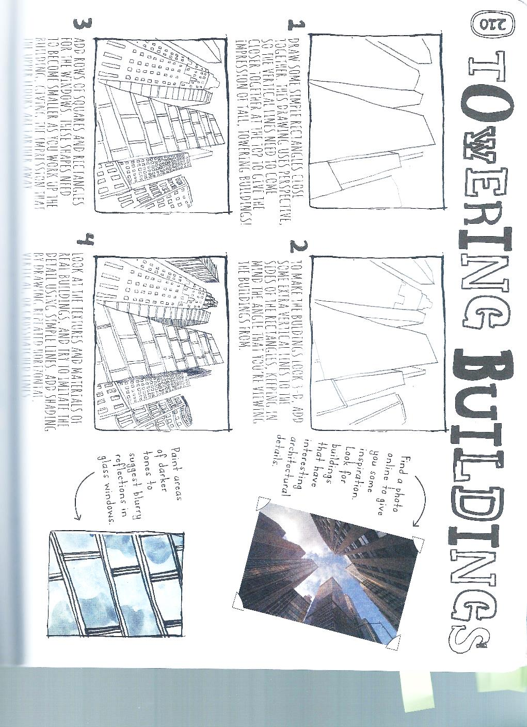

**Drawing & Painting Sketchbook Week 1- Towering Buildings Due: __________**

Draw a group of buildings from a photo or in person. Add doors, windows and architectural details. The picture below is an example.



**Drawing & Painting Sketchbook Week 1- Towering Buildings Due: __________**

Draw a group of buildings from a photo or in person. Add doors, windows and architectural details. The picture below is an example.