**Drawing & Painting Sketchbook Week 15- Submarine Due: __________**

Draw the Submarine with all the details showed below and create your own submarine creation from your imagination. Include details that would be appropriate for a submarine. A total of two drawings are required.

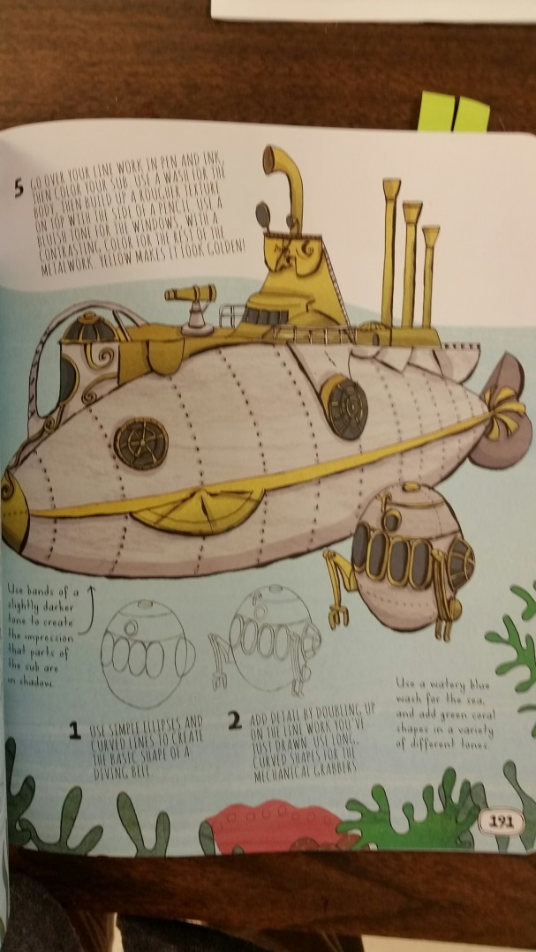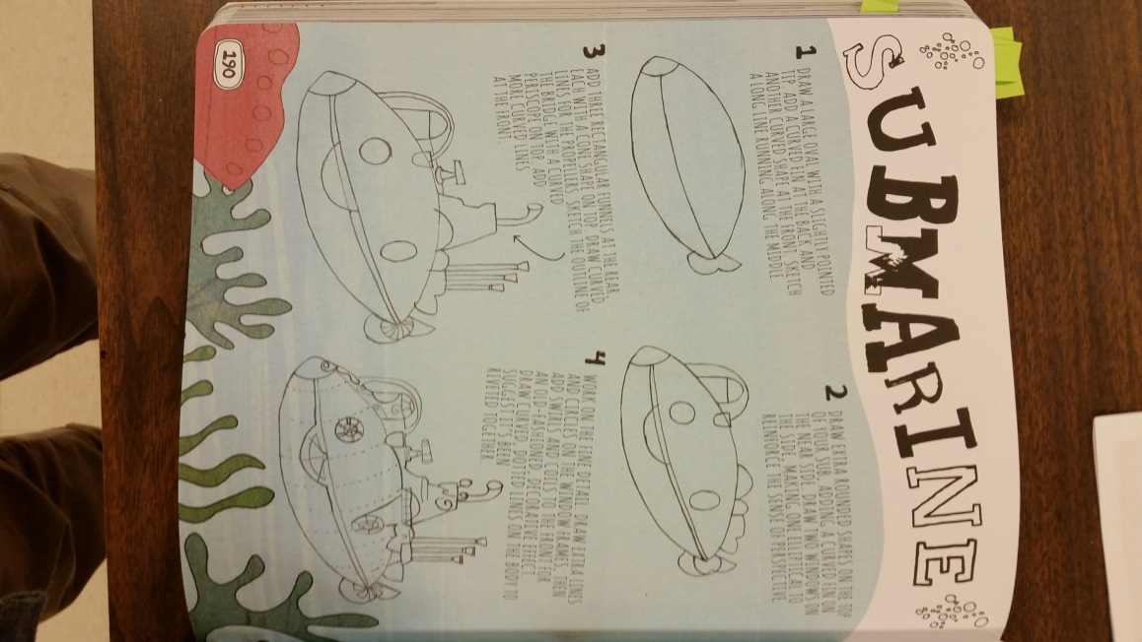****

**Drawing & Painting Sketchbook Week 15- Submarine Due: __________**

Draw the Submarine with all the details showed below and create your own submarine creation from your imagination. Include details that would be appropriate for a submarine. A total of two drawings are required.