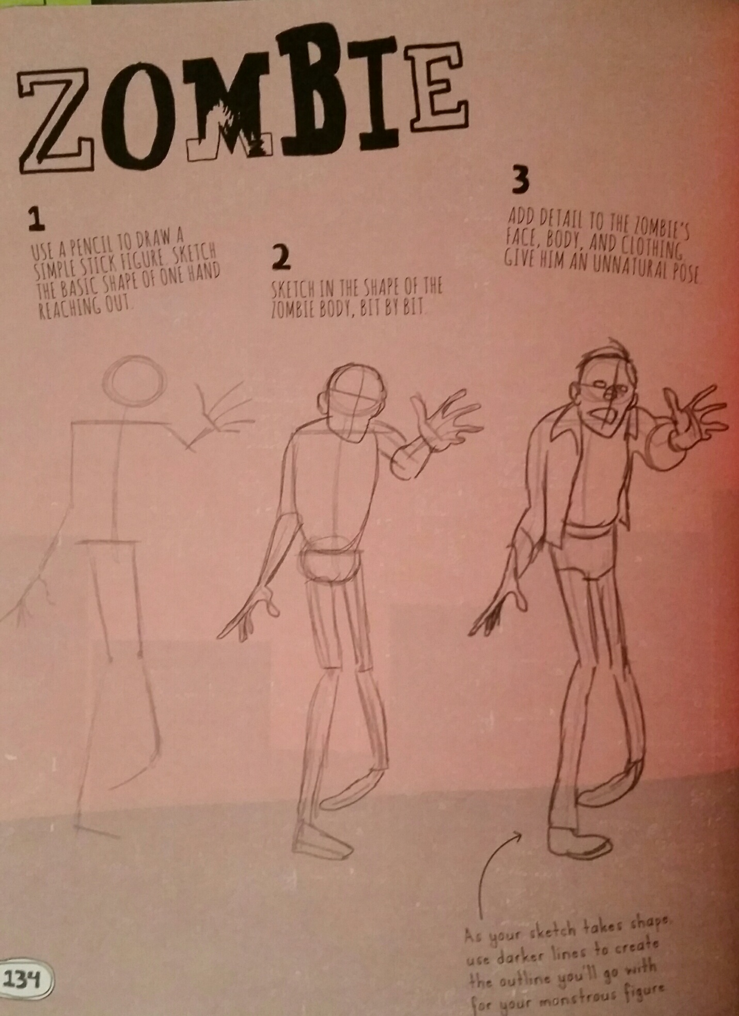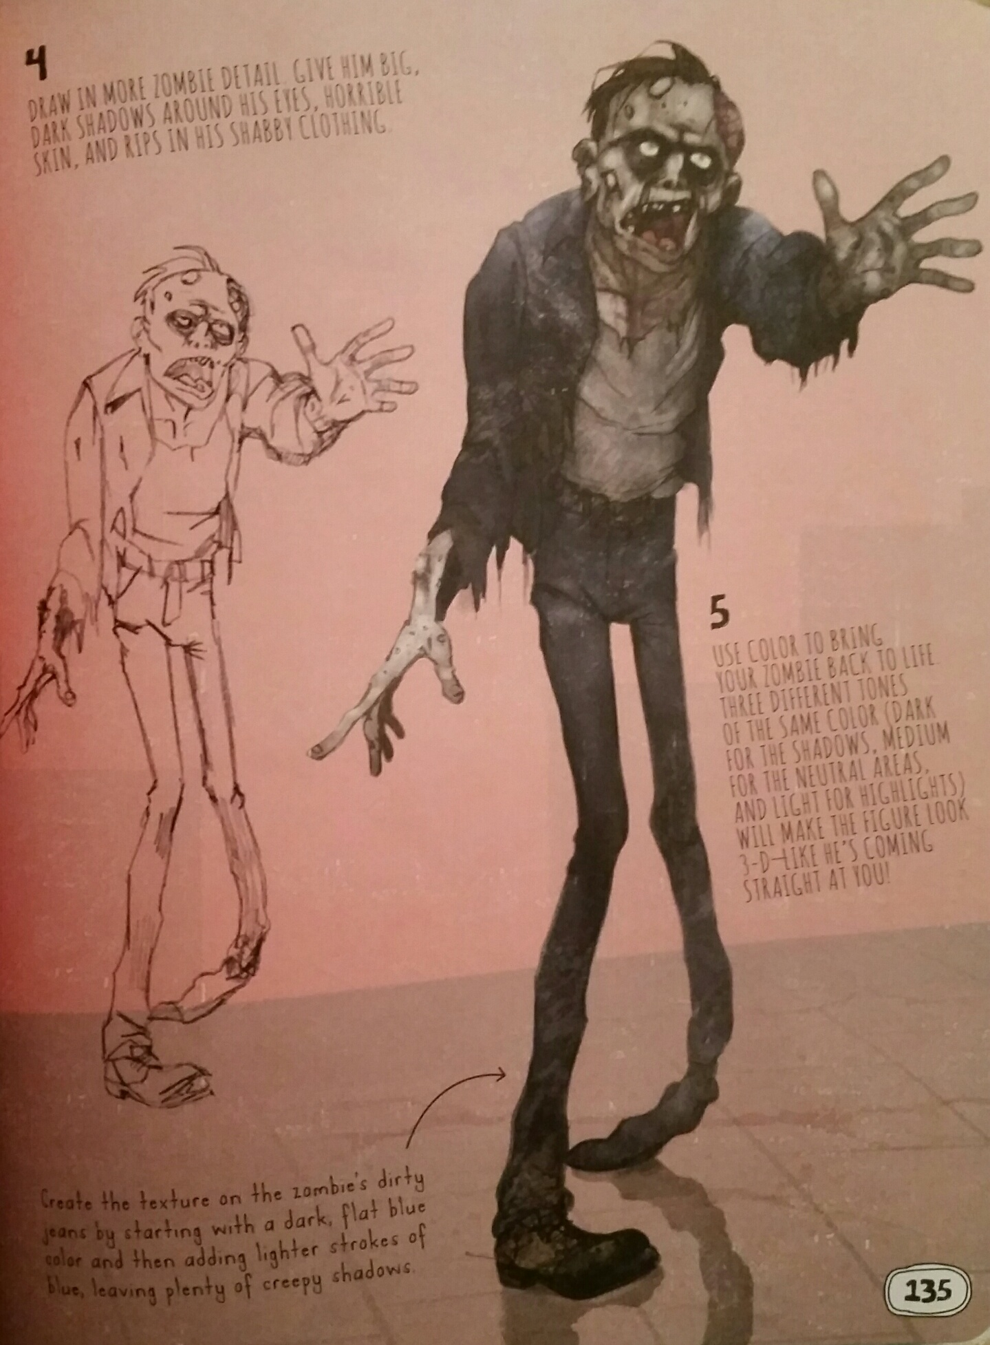

**Drawing & Painting Sketchbook Week 12- Zombies Due: __________**

Draw the Zombie below and create one from your imagination. Include details and clothing that would be appropriate for a Zombie. A total of two drawings are required.

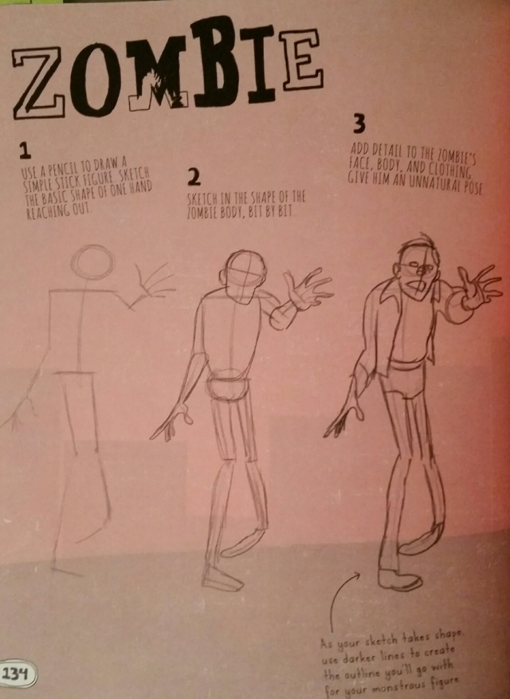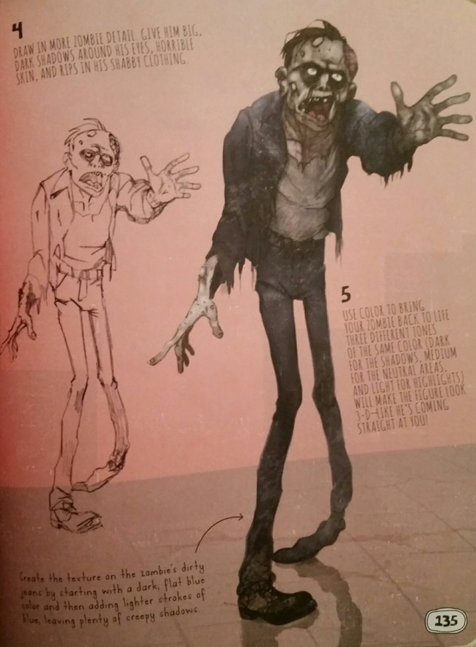

**Drawing & Painting Sketchbook Week 12- Zombies Due: __________**

Draw the Zombie below and create one from your imagination. Include details and clothing that would be appropriate for a Zombie. A total of two drawings are required.