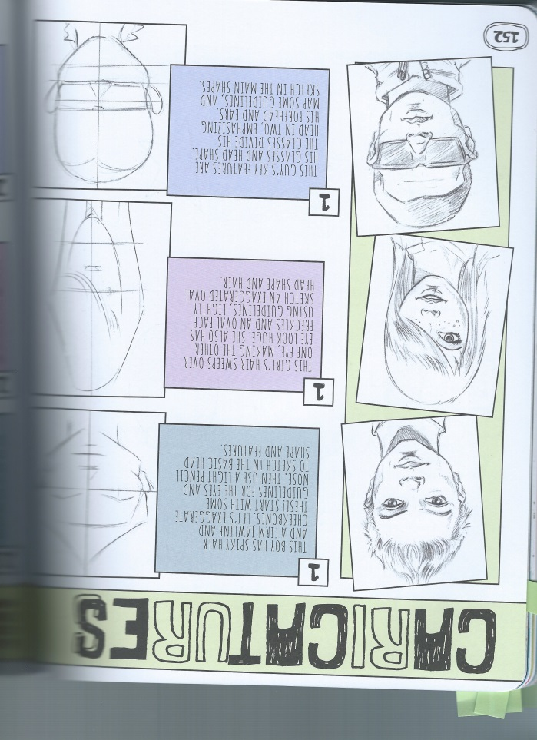

**Drawing & Painting Sketchbook Week 11- Caricatures Due: __________**

Draw 3 caricatures of people (famous people, friends, family or strangers) by exaggerating their facial features. You could make the face or any features taller, shorter, wider or slimmer. The images below are examples of three people and their caricatures. A total of three drawings are required.

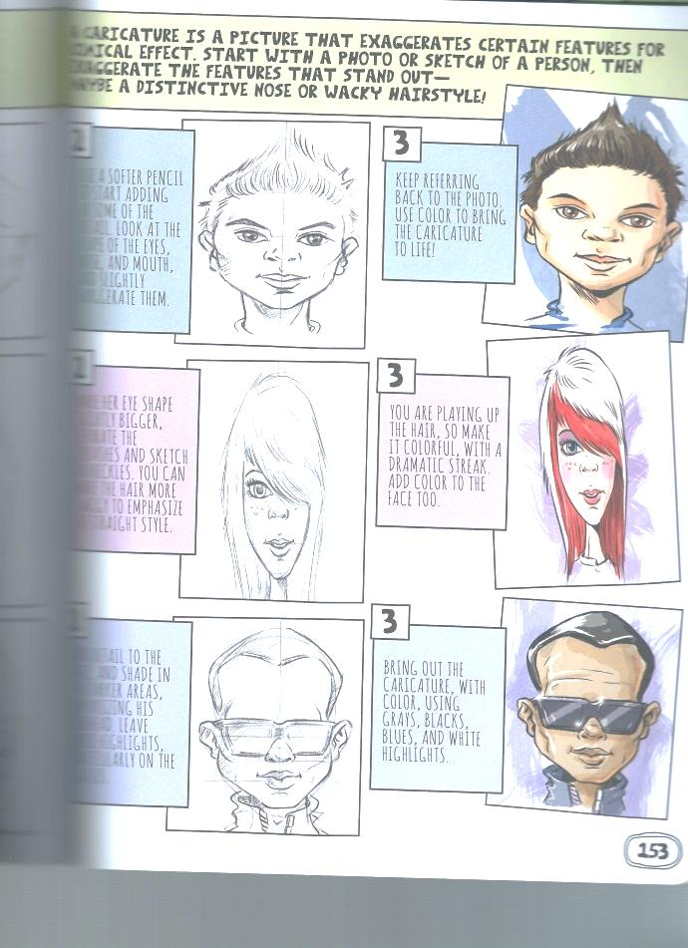

**Drawing & Painting Sketchbook Week 11- Caricatures Due: __________**

Draw 3 caricatures of people (famous people, friends, family or strangers) by exaggerating their facial features. You could make the face or any features taller, shorter, wider or slimmer. The images below are examples of three people and their caricatures. A total of three drawings are required.