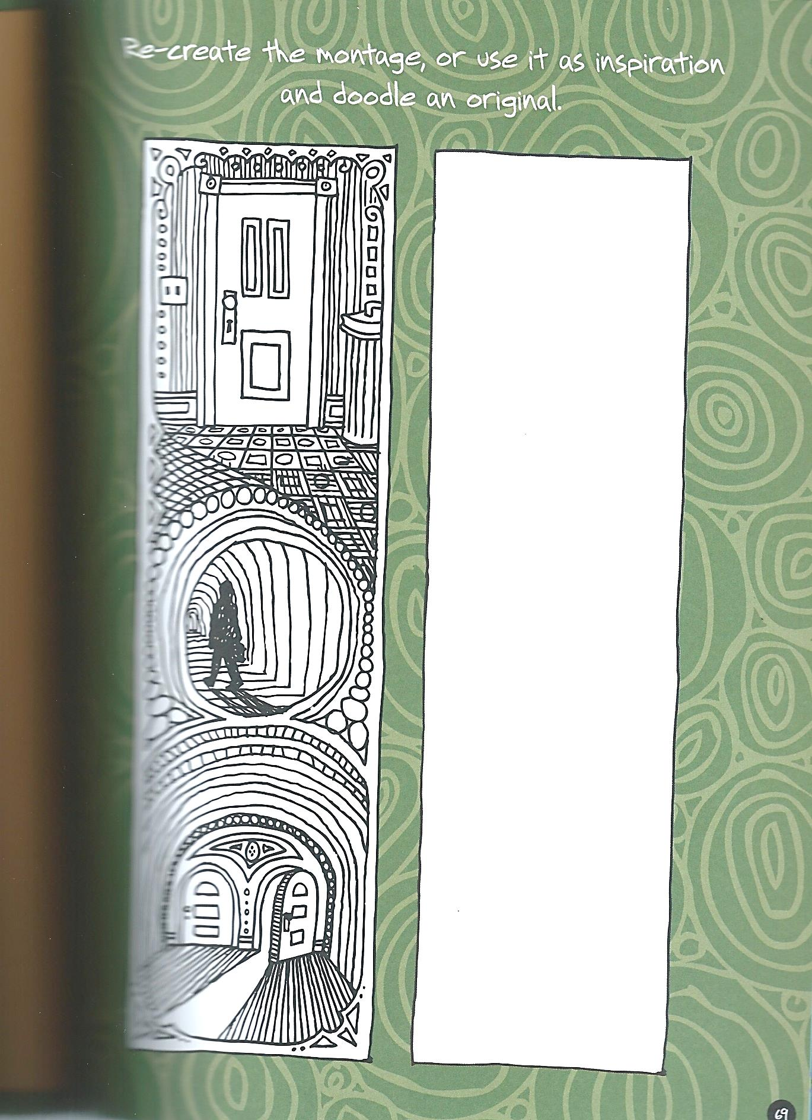

**Drawing & Painting Sketchbook Week 10- Doorways Due: __________**

Recreate the doorways below, then create your own doorway or passage way that includes details. A total of two drawings are due.



**Drawing & Painting Sketchbook Week 10- Doorways Due: __________**

Recreate the doorways below, then create your own doorway or passage way that includes details. A total of two drawings are due.