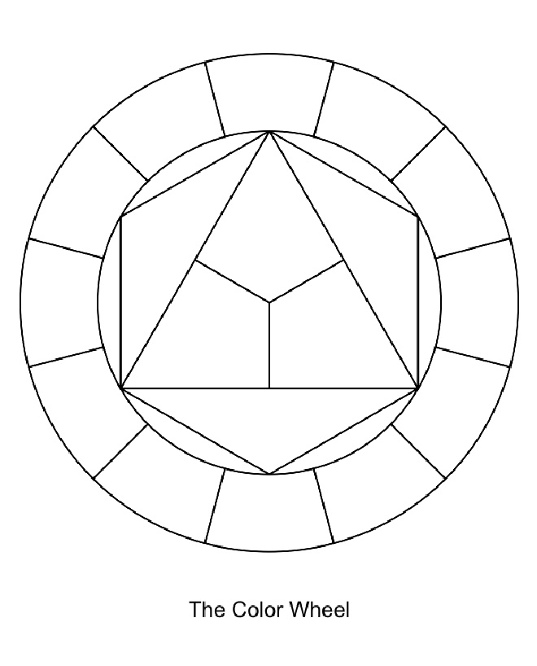

Cool Colors

S

S

S

S

S

**R O Y G B V**

Color: ______________________________________________

Primary Colors: ______________________________________

Secondary Colors: ____________________________________

Intermediate Colors: ___________________________________

Tint: ________________________________________________

Shade: ______________________________________________

Intensity: ____________________________________________

Value: ______________________________________________

**COLOR THEORY**

Monochromatic

Name:_______________________________ HR _____

S

S

S

S

Warm Colors

Analogous Colors

S

S

Complimentary Colors

S